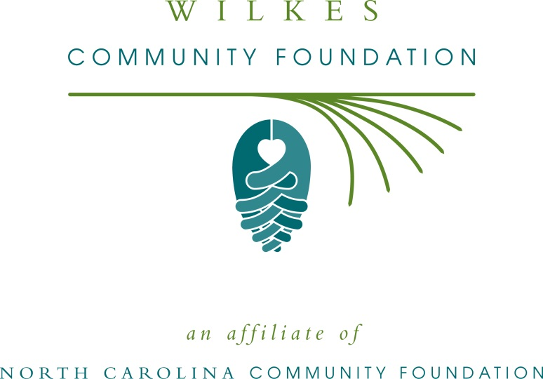

FOR IMMEDIATE RELEASE – 6/4/15

Wilkes Community Foundation accepting grant applications

The board of advisors of the Wilkes Community Foundation (WCF) is currently accepting grant requests for community projects funded from its community fund, according to Dennis Huggins, board president.

Funds are available for nonprofit organizations that serve general charitable needs in Wilkes County.

Applications are available online only. Visit nccommunityfoundation.org for information about applying online. The deadline for submitting applications is by noon Aug 4.

The Wilkes Community Foundation is an affiliate of the North Carolina Community Foundation. The community fund was established to help support local charitable needs through annual grants. In addition to Huggins, WCF board members are: Charlie White (vice-president), Jackie Hunnicutt (secretary-treasurer), Shanna Bell, Bill Clifton, Kenneth Foster, Jessica Inman George, Susan Cogdill, Bill Harris, Chad Martin, Amanda Perry, Jerry Smithey and Graham Wyche.

− MORE −

For further information, contact any board member; Northwestern Regional Associate John Francis at 336-745-1739 or visit the NCCF website at www.nccommunityfoundation.org.

About the North Carolina Community Foundation

The NCCF is the single statewide community foundation serving North Carolina and has made $89 million in grants since its inception in 1988. With more than $191 million in assets, NCCF sustains 1,200 endowments established to provide long-term support of a broad range of community needs, nonprofit organizations, institutions and scholarships. The NCCF partners with 60 affiliate foundations to provide local resource allocation and community assistance in 67 counties across the state. An important component of NCCF’s mission is to ensure that rural philanthropy has a voice at local, regional and national levels.

For more information, visit nccommunityfoundation.org and Facebook or follow on Twitter @NCCF.

- END -

NEWS MEDIA CONTACTS:
John Francis, Northwestern Regional Associate
336-745-1739
jfrancis@nccommunityfoundation.org
P.O. Box 2851
Hickory, NC 28601

Noel McLaughlin, Director, Marketing and Communications
North Carolina Community Foundation
919-256-6901
nmclaughlin@nccommunityfoundation.org

