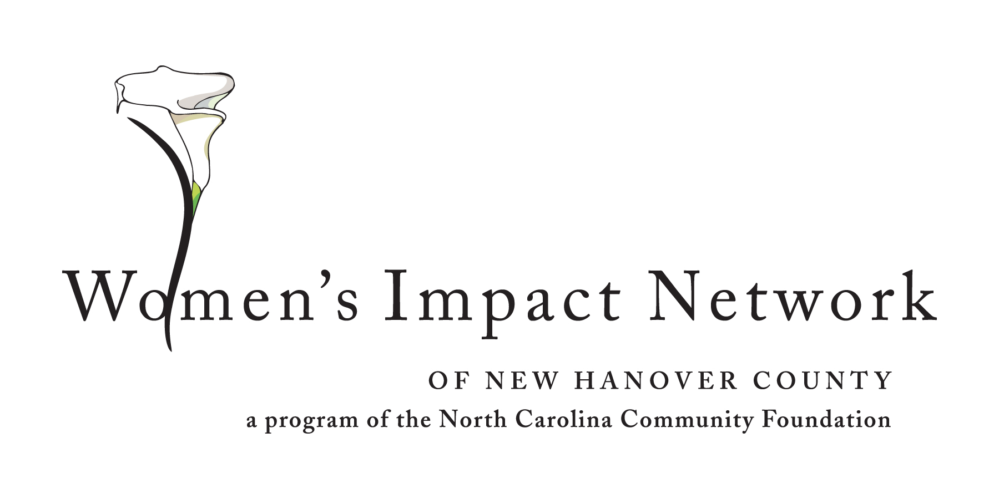
WOMEN’S IMPACT NETWORK OF NEW HANOVER COUNTY
INVITES PROPOSALS

FOR IMMEDIATE RELEASE
March 21, 2014

The Women’s Impact Network of New Hanover County, a women’s giving circle formed in partnership with the North Carolina Community Foundation, has announced its 2014 grants cycle with a focus on health and wellness needs of New Hanover County residents.

The Network invites area non-profits to submit a letter of inquiry explaining what a program might be able to do with a one-time grant of up to $32,000. Network members will use the letter of inquiry to identify organizations that most closely match the funding interests of the Women’s Impact Network.

Grant criteria and forms are available on the Women’s Impact Network web page, http://www.nccommunityfoundation.org/page/womens-impact-network-call-for-proposals , and proposals must be submitted electronically by Friday, April 4. Network members will review all proposals and select a limited number of organizations to submit full grant applications.

For more information about the Women’s Impact Network of New Hanover County, please contact Patricia Lawler, Regional Associate, North Carolina Community Foundation, at (910) 509-7256 or plawler@nccommunityfoundation.org.

###
About the North Carolina Community Foundation:

The NCCF is the single statewide community foundation serving North Carolina and has made nearly $74 million in grants since its inception in 1988. With more than $171 million in assets, NCCF sustains 1,200 endowments established to provide long-term support of a broad range of community needs, nonprofit organizations, institutions and scholarships. The NCCF partners with 60 affiliate foundations to provide local resource allocation and community assistance in 67 counties across the state. An important component of NCCF’s mission is to ensure that rural philanthropy has a voice at local, regional and national levels.
For more information, visit nccommunityfoundation.org and Facebook or follow on Twitter @NCCF.
# # #
NEWS MEDIA CONTACTS:
Patricia Lawler, NCCF Regional Associate
(910) 509-7256, plawler@nccommunityfoundation.org

Noel McLaughlin, NCCF Director, Marketing and Communications
919-256-6901; nmclaughlin@nccommunityfoundation.org

