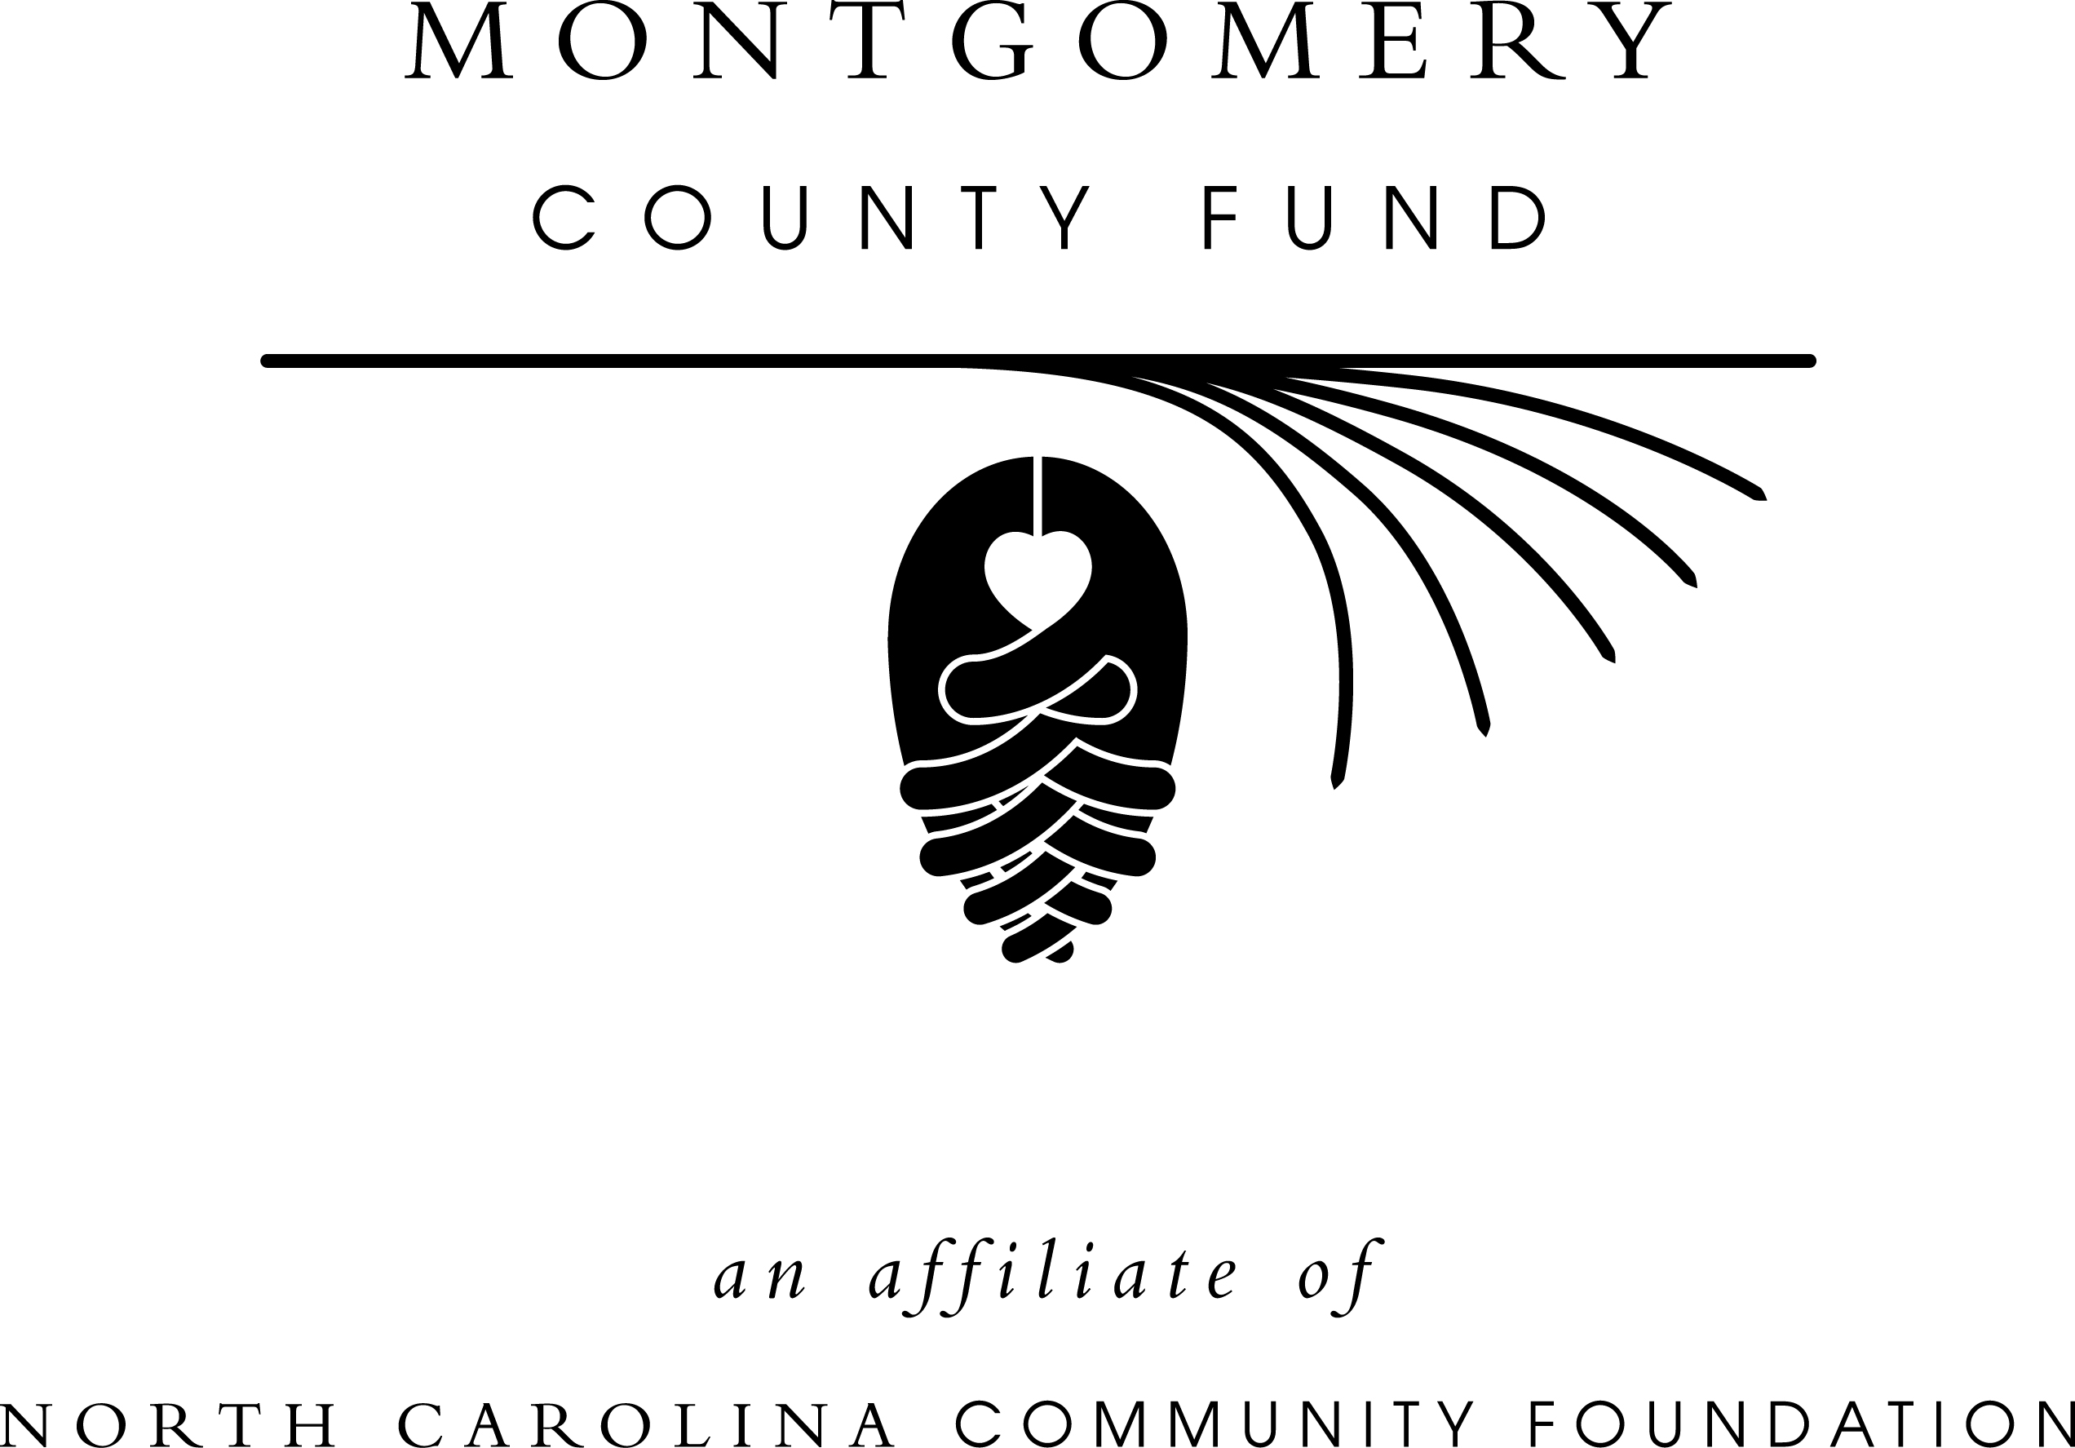

FOR IMMEDIATE RELEASE – September 26, 2013

Montgomery County Fund awards local grants

The board of advisors of the Montgomery County Fund announces 2013 awards from its community grantmaking fund, according to Kerry Hensley, board president. This year’s nonprofit recipients include:
- Carolina Cross Connection
- Central Park – STARworks programs
- Changing Lives Outreach Ministry
- Communities in Schools of Montgomery County
- East Montgomery High School
- Friends of the Montgomery County Public Libraries
- Highland Community Center
- Junior Achievement of Central North Carolina
- Montgomery County Cooperative Extension
- Land Trust for North Carolina
- Montgomery County Council on Aging
- Montgomery County Health Department Teen Pregnancy Program
- Montgomery County Partnership for Children
- Montgomery County Schools
- Mount Gilead Museum Foundation
- N.C. Cooperative Extension – Montgomery County
- Piedmont Art Guild
- Prevent Blindness NC
- Town of Star
- Trinity Music Academy
- West Montgomery High School
The awards were given at a dinner in Troy. The Montgomery County Fund’s board of advisors include Hensley, Vice President Judy Stevens, Jesse Capel, Earle Connelly, Brady Dickson, Win Dozier, Gordon Knowles, Sharon Matheny and Kim Woodard.
Hensley thanked the community for their support for their important work in Montgomery County and thanked members of the Montgomery County Fund board and the grants committee for their thoughtful consideration during the grant awards process. “These grants are important to our community and our quality of life,” she said. “Critical programs would not be possible without the generosity of many individuals and organizations that have supported the Montgomery County Fund.”
The Montgomery County Fund is an affiliate of the North Carolina Community Foundation. Tax-deductible contributions can be made to the Montgomery County Fund. Contributions should be made payable to the Montgomery County Fund P.O. Box 116, Troy, NC 27371. Contributions can also be made online at www.nccommunityfoundation.org.
For information on the Montgomery County Fund and its community grantmaking program, contact Hensley or Mary Anne Howard, regional associate, at 919-256-6924 or visit the NCCF website at www.nccommunityfoundation.org and click on “Affiliates.”
About the North Carolina Community Foundation:

The NCCF is the single statewide community foundation serving North Carolina and has made nearly $74 million in grants since its inception in 1988. With more than $170 million in assets, NCCF sustains 1,200 endowments established to provide long-term support of a broad range of community needs, nonprofit organizations, institutions and scholarships. The NCCF partners with 60 affiliate foundations to provide local resource allocation and community assistance in 67 counties across the state. An important component of NCCF’s mission is to ensure that rural philanthropy has a voice at local, regional and national levels.
For more information, visit www.nccommunityfoundation.org and Facebook or follow on Twitter @NCCF.
# # #
NEWS MEDIA CONTACTS:
Mary Anne Howard
919-256-6924
mhoward@nccommunityfoundation.org

Noel McLaughlin, NCCF Director, Marketing and Communications
919-256-6901
nmclaughlin@nccommunityfoundation.org

