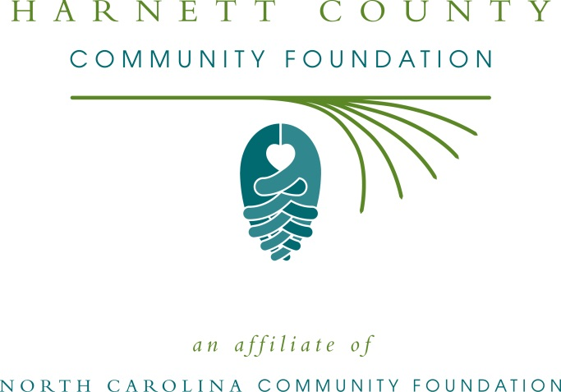

FOR IMMEDIATE RELEASE – 6/4/15

Harnett County Community Foundation accepting grant applications

The board of advisors of the Harnett County Community Foundation (HCCF) is currently accepting grant requests for community projects funded from its community fund, according to Mary Ellen Lauder, board president.

Funds are available for nonprofit organizations that serve general charitable needs in Harnett County.

Applications are available online only. Visit nccommunityfoundation.org for information about applying online. The deadline for submitting applications is by noon Aug 4.

The Harnett County Community Foundation is an affiliate of the North Carolina Community Foundation. The community fund was established to help support local charitable needs through annual grants. In addition to Lauder, HCCF board members are: Dawn Neighbors (secretary), Joseph Giles (treasurer), J. Dal Snipes (past-president), Bart Adams, Ernest Alphin, Charles W. Carpenter, Robert B. Carr, Dallas L. Dafford, Bob Doberstein, Keith G. Finch, Kim Hargrove, Oscar N. Harris, David Hodges, Ester H. Howard, Marsha Johnson, Clem Medley, Tilghman Pope, William R. Pope, Coley Price, Rhett Raynor, H. L. Sorrell, Jr., Kathryn Tart, Doug Turner and Bobby Wellons.

− MORE −

For further information, contact any board member; the Sandshills Regional Associate Mary Anne Howard at 919-256-6924 or visit the NCCF website at www.nccommunityfoundation.org.

About the North Carolina Community Foundation

The NCCF is the single statewide community foundation serving North Carolina and has made $89 million in grants since its inception in 1988. With more than $191 million in assets, NCCF sustains 1,200 endowments established to provide long-term support of a broad range of community needs, nonprofit organizations, institutions and scholarships. The NCCF partners with 60 affiliate foundations to provide local resource allocation and community assistance in 67 counties across the state. An important component of NCCF’s mission is to ensure that rural philanthropy has a voice at local, regional and national levels.

For more information, visit nccommunityfoundation.org and Facebook or follow on Twitter @NCCF.

- END -

NEWS MEDIA CONTACTS:
Mary Anne Howard, Sandhills Regional Associate
919-256-6924
mhoward@nccommunityfoundation.org
4601 Six Forks Road, Suite 524
Raleigh, NC 27609

Noel McLaughlin, Director, Marketing and Communications
North Carolina Community Foundation
919.256-6901
nmclaughlin@nccommunityfoundation.org

