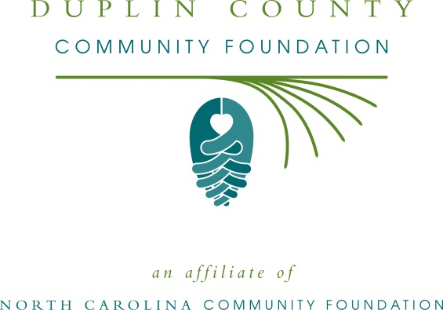
FOR IMMEDIATE RELEASE - June 12, 2015
Duplin Foundation for Youth Advancement grant application cycle opens June 26
KENANSVILLE – Online grant applications for the Duplin Foundation for Youth Advancement will be available June 26 through noon Aug. 11 on the North Carolina Community Foundation website. Grant recipients will be announced in September.
The Duplin County Community Foundation will host a grant information session on Thursday, June 25 from 3:00 to 4:00pm, in the auditorium of James Sprunt Community College. The workshop is free, but registration is required. The Foundation strongly encourages applicants to send a representative and/or grantwriter to this session.
Proceeds from the annual Sheriff’s Ball support the Duplin Foundation for Youth Advancement, which is a program of the Duplin County Community Foundation. In 2014, the Foundation awarded more than $40,000 in grants to 10 local youth initiatives. This year, the Foundation again hopes to award $40,000 in grants through the competitive online application process.
The mission of the Duplin Foundation for Youth Advancement is to inspire Duplin County citizens to make lasting and meaningful contributions to our community that benefit our children.
Grants are available to local organizations with programs focusing on youth in Duplin County. Priority is given to proposals that incorporate a holistic approach and include one or more of the following focus areas:
- Motivate youth to stay and succeed in school
- Foster positive youth-adult engagement through mentoring
- Strengthen gang awareness and prevention efforts
- Promote participation in philanthropy
- Provide leadership opportunities and employment skills training
- Increase likelihood of a successful transition to adulthood
- Develop financial literacy
- Encourage engagement in community service
- Promote mental and physical health and well-being
All applicants must use the online application system at www.nccommunityfoundation.org. The review committee will only consider complete application packets. Grants may range from $500 to $5,000.
Those eligible to make application are:
- Organizations that are qualified as tax-exempt public charities under Section 501(c)(3) of the Internal Revenue Code or be classified as a unit of government. If an organization operates as a 501(c)(3) public charity via a fiscal agent, included in the application must be a letter from the fiscal agent organization that verified the relationship and includes when the relationship was established.
- Faith-based organizations that support social outreach and charitable service programs to benefit the community at large.
- Organizations that offer programs and services without discrimination on the basis of age, race, national origin, ethnicity, gender, physical ability, sexual orientation, political affiliation or religious belief.
Grants will not be awarded for annual funds, capital campaigns, capital improvements, political purposes or lobbying, activities restricted to members of a particular faith community or to promote a specific religious doctrine, loans or reimbursements, to individuals, or for re-granting by the applicant organization.
The 2016 Sheriff’s Ball is scheduled for April 2, 2016 at the River Landing Clubhouse.
For additional information, contact Angie Brewer, NCCF regional associate, at 910-509-7256 or abrewer@nccommunityfoundation.org. Go online to www.nccommunityfoundation.org, June 26 through noon Aug. 11, to complete a grant application
The Duplin County Community Foundation is an affiliate of NCCF, which provides technical assistance and management services. Anyone wishing to learn more about the Duplin County Foundation or the Duplin Foundation for Youth Advancement may contact a local board member or call the North Carolina Community Foundation’s Southeastern office at (910) 509-7256.
NCCF is the single statewide community foundation serving North Carolina and has made $89 million in grants since its inception in 1988. With more than $191 million in assets, NCCF sustains 1,200 endowments established to provide long-term support of a broad range of community needs, nonprofit organizations, institutions and scholarships. The NCCF partners with 60 affiliate foundations to provide local resource allocation and community assistance in 67 counties across the state. An important component of NCCF’s mission is to ensure that rural philanthropy has a voice at local, regional and national levels. For more information, visit nccommunityfoundation.org and Facebook or follow on LinkedIn and Twitter @NCCF.
###
News Media Contact:
Angie Brewer
910-509-7256
abrewer@nccommunityfoudnation.org

