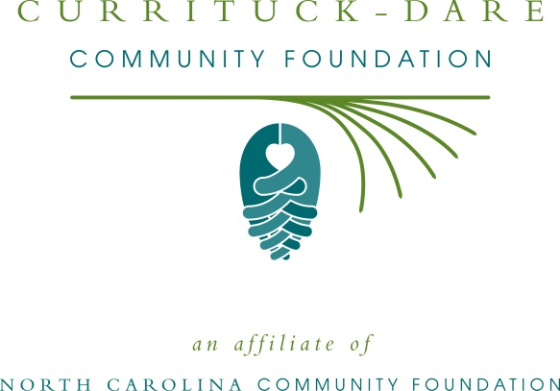
FOR IMMEDIATE RELEASE – 6/16/15
Currituck-Dare Community Foundation and Women’s Giving Circle accepting grant applications
The board of advisors of the Currituck-Dare Community Foundation (CDCF) will be accepting grant requests beginning June 26 for nonprofit projects funded from its community fund, according to Janet Colegrove, board president. Funds are available for nonprofit organizations that serve general charitable needs in Dare and Currituck counties.
Hannah Robinson, grants chair, said the CDCF generally focuses on nonprofits that support community needs. “We know that these grants will have a large and immediate impact on the work that they’re doing,” she said.
The Currituck-Dare Women’s Giving Fund, a program of the CDCF, provides grants to nonprofit organizations that serve the needs of women and children in Dare and Currituck counties.
Applications are available online only at the North Carolina Community Foundation’s website. Visit nccommunityfoundation.org for more information and to apply online. Applications are due by noon Aug. 11. Only completed applications will be considered.
This year’s Duck & Wine Festival, CDCF’s annual fundraiser, earned over $17,800 that was divided among its community grantmaking fund, Currituck Kids, Kids First, and other nonprofit partners.
The CDCF is an affiliate of the North Carolina Community Foundation. The community fund was established to help support local charitable needs through annual grants. In addition to Colegrove and Robinson, Currituck-Dare Community Foundation board members are: Jim Troutman, vice president, Patty Guillaume, secretary, Linda Algood, Lynne Alterman, Karen Etheridge, Scott Foster, Nancy Proctor, and Scott Blackstock.
For further information, contact any board member, NCCF Regional Associate Natalie Jenkins Peel at (252) 216-8908, or visit the NCCF website at nccommunityfoundation.org.
About the North Carolina Community Foundation
The NCCF is the single statewide community foundation serving North Carolina and has made nearly $74 million in grants since its inception in 1988. With more than $171 million in assets, NCCF sustains 1,200 endowments established to provide long-term support of a broad range of community needs, nonprofit organizations, institutions and scholarships. The NCCF partners with 60 affiliate foundations to provide local resource allocation and community assistance in 67 counties across the state. An important component of NCCF’s mission is to ensure that rural philanthropy has a voice at local, regional and national levels.
For more information, visit nccommunityfoundation.org and Facebook or follow on Twitter @NCCF.
# # #
NEWS MEDIA CONTACTS:
Natalie Jenkins Peel, NCCF Regional Associate
252-216-8908; npeel@nccommunityfoundation.org
Noel McLaughlin, NCCF Director, Marketing and Communications
919-256-6901; nmclaughlin@nccommunityfoundation.org

Cutline for attached photo:
Tommy Karole (middle), owner of Paper Canoe and Best Dish award winner, poses with Janet Colegrove (left), President of the CDCF board, and Loismary Hoehne (right), President of Food for Thought, a nonprofit partner receiving their donation.

