.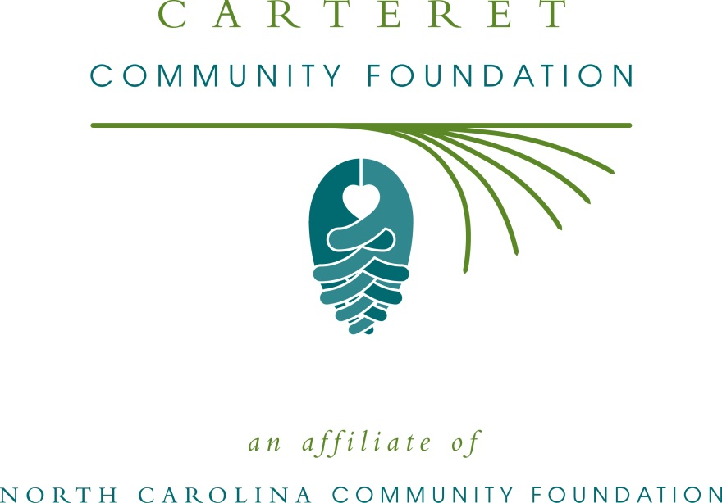
Carteret Community Foundation accepting grant applications
For immediate release -- 7/18/16
The board of advisors of the Carteret Community Foundation is currently accepting grant requests for projects funded from its community grantmaking fund, Pearl’s Pantry Fund, the J.O. & Ruth Barbour Memorial Fund for Elementary Education in Carteret County and the J.O. & Ruth Barbour Memorial Fund for Wildlife Habitat Conservation, according to Richard McIntyre, board president.
Community grantmaking funds are available for nonprofit organizations that serve general charitable needs in Carteret County. Applications are available beginning July 22. Visit nccommunityfoundation.org for information about applying. The deadline for submitting applications is noon Aug. 23.
The Pearl’s Pantry Fund was established by V.J. “Puck” O’Neal in honor of his beloved wife, Pearl, according to McIntyre. “It was Mr. O’Neal’s intention to use the proceeds from this endowment fund to help local nonprofit organizations relieve hunger and lack of access to quality prescription medicines for less fortunate citizens of Carteret County,” he said.
The J.O. & Ruth Barbour Memorial Fund for Elementary Education in Carteret County supports Carteret County elementary schools with basic instruction, classroom equipment, teacher compensation, and facility improvement in order to contribute to better instruction for all.
The J.O. & Ruth Barbour Memorial Fund for Wildlife Habitat Conservation supports conservation projects in Carteret County that would contribute to the preservation, maintenance or reestablishment of woodland and other natural areas that provide suitable and desirable habitats for wildlife, with particular emphasis on birdlife.
The Carteret Community Foundation is an affiliate of the North Carolina Community Foundation. The community fund was established to help support local charitable needs through annual grants. In addition to McIntyre, board members are: Frank Kivett (vice-president), Rhonda Scibal (secretary), Charles Jordan (treasurer), Peggy Burns, Eric Gregson, Ray Harris, Debra Harvell, Beth Henry, John Humphries, Charles Jordan, Corey Lewis, Jimmy Mercer, Ryan Morris, Ginger Parker, Terry Robertson and Brian Watson.
For further information, contact NCCF Regional Director Kim Ball at 252-288-5706 or kball@nccommunityfoundation.org or visit the NCCF website at nccommunityfoundation.org.
About the North Carolina Community Foundation
The NCCF is the single statewide community foundation serving North Carolina and has made $101 million in grants since its inception in 1988. With more than $237 million in assets, NCCF sustains 1,200 endowments established to provide long-term support of a broad range of community needs, nonprofit organizations, institutions and scholarships. The NCCF partners with 60 affiliate foundations to provide local resource allocation and community assistance in 67 counties across the state. An important component of NCCF’s mission is to ensure that rural philanthropy has a voice at local, regional and national levels.
For more information, visit nccommunityfoundation.org, like us on Facebook and follow us on LinkedIn and Twitter @NCCF.
Media contact
Kim Ball; NCCF Regional Director
252-288-5706; kball@nccommunityfoundation.org

