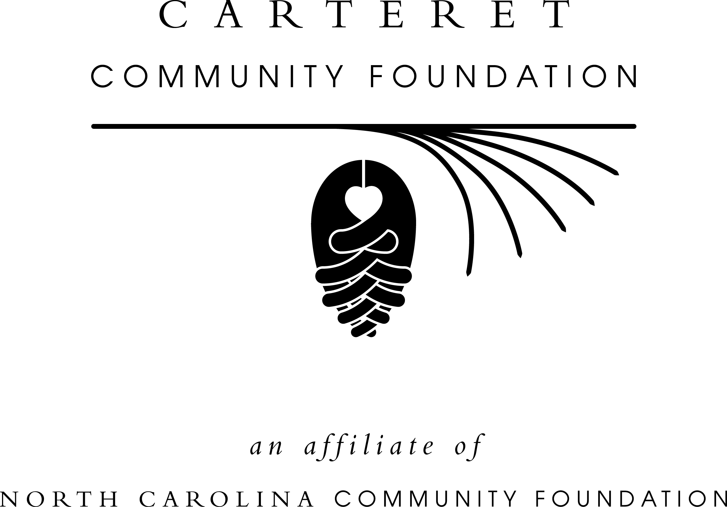
For immediate release
March 25, 2015
PEARL’S PANTRY FUND ACCEPTING GRANT APPLICATIONS
The board of advisors of the Carteret Community Foundation announces that it will begin accepting grant applications from Pearl’s Pantry Fund on Friday, March 20. The deadline to apply is April 28 at noon.
Applications are available online only. Visit nccommunityfoundation.org and click on the Carteret Community Foundation page for information about applying online.
To be eligible, organizations must be public charities or religious institutions located in Carteret County, with all funds used to benefit Carteret County residents.
Pearl’s Pantry Fund was established by V.J. “Puck” O’Neal in honor of his beloved wife, Pearl, according to Richard McIntyre, president of the Carteret Community Foundation. “It was Mr. O’Neal’s intention to use the proceeds from this endowment fund to help local nonprofit organizations relieve hunger and lack of access to quality prescription medicines for less fortunate citizens of Carteret County,” he said.
The Carteret Community Foundation will award this year’s grants on June 11 to honor the late Pearl O’Neal on her birthday.
About the Carteret Community Foundation
The Carteret Community Foundation was established in 1984 and is an affiliate of the North Carolina Community Foundation (NCCF). The Carteret Community Foundation provides grants to local nonprofits, college scholarships to county students and works through NCCF to help professional advisors, individuals, families and nonprofit agencies establish endowments.
Tax-deductible contributions in any amount can be made to the Carteret County Unrestricted Endowment Fund and mailed to the Carteret Community Foundation, c/o NCCF, P.O. Box 3411, New
MORE
Bern, NC 28564. For more information about the Carteret Community Foundation and its services, please visit the Carteret page on nccommunityfoundation.org or contact NCCF Regional Associate Kim Ball at 252-288-5706.
About the North Carolina Community Foundation
The NCCF is the single statewide community foundation serving North Carolina and has made nearly $89 million in grants since its inception in 1988. With more than $191 million in assets, NCCF sustains 1,200 endowments established to provide long-term support of a broad range of community needs, nonprofit organizations, institutions and scholarships. The NCCF partners with 60 affiliate foundations to provide local resource allocation and community assistance in 67 counties across the state. An important component of NCCF’s mission is to ensure that rural philanthropy has a voice at local, regional and national levels. For more information, visit nccommunityfoundation.org and Facebook or follow on LinkedIn and Twitter @NCCF
###
Media contact
Kim Ball
NC Community Foundation
Regional Associate, Coastal Plain South
252-288-5706
kball@nccommunityfoundation.org

