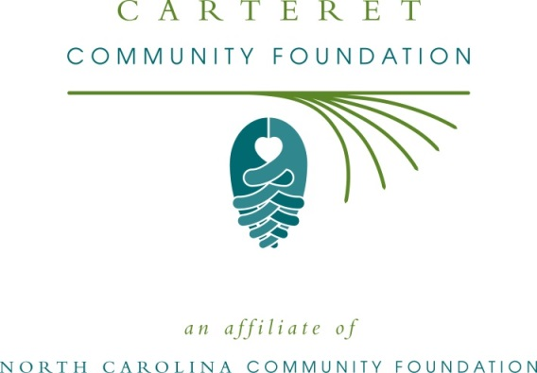

Carteret Community Foundation awards “Pearls Pantry” grant to area nonprofit
For immediate release: June 20, 2014
The board of advisors of the Carteret Community Foundation announces that the 2014 “Pearl’s Pantry” grant has been awarded to the Broad Street Clinic Foundation.

The mission of the Broad Street Clinic is to provide health services to local uninsured, low income residents who suffer from certain chronic diseases and are unable to afford regular visits to a local healthcare provider. The Clinic has been operating since 1993.

The Pearl’s Pantry Fund was established by V.J. “Puck” O’Neal in honor of his beloved wife, Pearl. It is O’Neal’s intention that this endowment will provide new funding to relieve hunger and increase access to quality prescription medicines for the less fortunate citizens of Carteret County.

“It is our privilege to help realize Mr. O’Neal’s dream that all Carteret County citizens have access to adequate food and medicines, said Carteret Community Foundation Chairman Pat Rauhauser.

About the Carteret Community Foundation
The Carteret Community Foundation was established in 1984 by a group of citizens with the mission to “enhance the quality of life in Carteret County through giving.” The Carteret Community Foundation, an affiliate of the North Carolina Community Foundation, provides grants to local nonprofits, college scholarships to county students and partners with professional advisors who can help individuals, families, organizations and nonprofits establish endowments or designated funds for specific charitable purposes.
Tax-deductible contributions in any amount can be made to the Carteret County Unrestricted Endowment Fund and mailed to P.O. Box 3454, Morehead City, NC 28557. For more information about the Foundation or starting your own endowment, please contact Kim Ball, NCCF regional associate, at kball@nccommunityfoundation.org or 252-288-5706
About the North Carolina Community Foundation
The NCCF is the single statewide community foundation serving North Carolina and has made nearly $74 million in grants since its inception in 1988. With more than $171 million in assets, NCCF sustains 1,200 endowments established to provide long-term support of a broad range of community needs, nonprofit organizations, institutions and scholarships. The NCCF partners with 60 affiliate foundations to provide local resource allocation and community assistance in 67 counties across the state. An important component of NCCF’s mission is to ensure that rural philanthropy has a voice at local, regional and national levels.
For more information, visit nccommunityfoundation.org and Facebook or follow on Twitter @NCCF.

News media contacts:
Kim Ball, NCCF Regional Associate
kball@nccommunityfoundation.org
252-288-5706

Noel McLaughlin, NCCF Director of Marketing and Communications
nmclaughlin@nccommunityfoundation.org
919-256-6901

