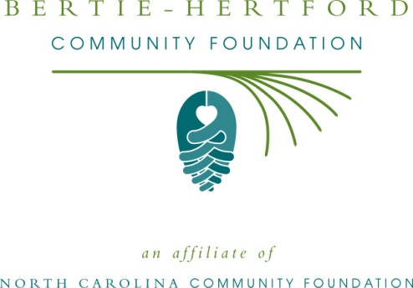

The
Bertie-Hertford Board of Directors
Invites you
To a Community Reception
Date: April 16, 2013
Location: St. Thomas Episcopal Church
302 S. Queen St., Windsor, NC
Time: 5:00-6:30 PM
Special guest speakers:
Beth Boney Jenkins, NCCF Dir. of Development
Sally Migliore, NCCF Director of Community Leadership
RSVP by April 10:
Email: pbirknccommf@embarqmail.com
Phone: 252-491-8166

Hosted by the
Bertie-Hertford Community Foundation

President, Laura Beasley
Vice President, John M. Tayloe
Sec/Treas: Marti Tyler
John H. Davis
Dr. Beverly Edwards
Austine Evans
Carole C. Everett
Richard Hoggard
Karen Ray
Penny Rose
Lindsay G. Vaughan
Ron Wesson

Director Emeritus:
Wayland Jenkins

The Bertie-Hertford Community Foundation is one of 60
Affiliate partners of the North Carolina Community Foundation. BHCF was organized in 1999 and serves 32 local funds, local nonprofits, and our communities through philanthropic services.
www.nccommunityfoundation.org

