Novel genetic subgroups inform on shared pathobiology within adult and pediatric Burkitt lymphoma
Nicole Thomas¹, Kostiantyn Dreval¹, Daniela S. Gerhard², Laura K. Hilton³, Jeremy S. Abramson⁴, Nancy L. Bartlett⁵, Jeffrey Bethony⁶, Jay Bowen⁷, Anthony C. Bryan⁷, Corey Casper⁸, Manuela Cruz¹, Maureen Dyer⁹, Julie M. Gastier-Foster^{7,10}, Alina Gerrie³, Bruno M. Grande¹¹, Timothy Greiner¹², Nicholas B. Griner², Thomas G. Gross¹³, Nancy Lee Harris¹⁴, John D. Irvin¹⁵, Elaine S. Jaffe¹⁶, Fabio Leal¹⁷, Jean Paul Martin¹⁵, Marie-Reine Martin¹⁵, Sam M. Mbulaiteye¹⁸, Charles G. Mullighan¹⁹, Andrew J. Mungall²⁰, Karen Mungall²⁰, Constance Namirembe²¹, Ariela Noy²², Martin D. Ogwang²³, Jackson Orem²¹, German Ott²⁴, Hilary Petrello⁷, Steven J. Reynolds²⁵, Shaghayegh Soudi¹, Steven H. Swerdlow²⁶, Alexandra Traverse-Glehen²⁷, Wyndham H. Wilson²⁸, Jasper Wong³, Marco A. Marra^{20,29}, Louis M. Staudt²⁸, David W. Scott³ & Ryan D. Morin^{1,20}
¹Department of Molecular Biology and Biochemistry, Simon Fraser University, Burnaby, BC, Canada.

²Office of Cancer Genomics, National Cancer Institute, National Institutes of Health, Bethesda, MD, USA.

³Centre for Lymphoid Cancer, BC Cancer, Vancouver, BC, Canada.

⁴Center for Lymphoma, Massachusetts General Hospital, Harvard Medical School, Boston, MA, USA.

⁵Washington University School of Medicine, St. Louis, MO, USA.

⁶George Washington University, Washington, DC, USA.

⁷Biopathology Center, Nationwide Children's Hospital, Columbus, OH, USA.

⁸Infectious Disease Research Institute, Seattle, WA, USA.

⁹Clinical Research Directorate, Frederick National Laboratory for Cancer Research sponsored by the National Cancer Institute, Frederick, MD, USA.

¹⁰Departments of Pathology and Pediatrics, The Ohio State University, Columbus, OH, USA.

¹¹Sage Bionetworks, Seattle, WA, USA.

¹²Department of Pathology and Microbiology, University of Nebraska Medical Center, Omaha, NE, USA.

¹³Center for Global Health, National Cancer Institute, National Institutes of Health, Rockville, MD, USA.

¹⁴Department of Pathology, Massachusetts General Hospital, Harvard Medical School, Boston, MA, USA.

¹⁵Foundation for Burkitt Lymphoma Research, Geneva, Switzerland.

¹⁶Laboratory of Pathology, Clinical Center, National Cancer Institute, National Institutes of Health, Bethesda, MD, USA.

¹⁷Programa de Oncovirologia, Instituto Nacional de Cancer Jose de Alencar, Rio de Janeiro, Brazil.

¹⁸Division of Cancer Epidemiology and Genetics, National Cancer Institute, National Institutes of Health, Rockville, MD, USA.

¹⁹Department of Pathology, St. Jude Children's Research Hospital, Memphis, TN, USA.

²⁰Canada's Michael Smith Genome Sciences Centre at BC Cancer, Vancouver, BC, Canada.

²¹Uganda Cancer Institute, Kampala, Uganda.

²²Memorial Sloan Kettering Cancer Center and Weill Cornell Medical College, New York, NY, USA.

²³EMBLEM Study, St. Mary's Hospital Lacor, Gulu, Uganda.

²⁴Department of Clinical Pathology, Robert-Bosch-Krankenhaus and Dr. Margarete Fischer-Bosch Institute of Clinical Pharmacology, Department of Clinical Pathology, Stuttgart, Germany.

²⁵Division of Intramural Research, National Institute of Allergy and Infectious Diseases, National Institutes of Health, Bethesda, MD, USA.

²⁶Division of Hematopathology, University of Pittsburgh School of Medicine, Pittsburgh, Pennsylvania, USA.

²⁷Hospices Civils de Lyon, Université Lyon 1, Service d'Anatomie Pathologique, Hopital Lyon Sud France.

²⁸Lymphoid Malignancies Branch, Center for Cancer Research, National Cancer Institute, Bethesda, MD, USA.

²⁹Department of Medical Genetics, University of British Columbia, Vancouver, BC, Canada.

Introduction: Burkitt lymphoma (BL) accounts for approximately 50% of all pediatric non-Hodgkin lymphomas compared to 1-2% in adults. Adult BL (aBL) remains a poorly understood entity and its relationship to pediatric BL (pBL) and to DLBCL has not been fully elucidated. The variable treatment outcomes between these entities necessitate a more thorough understanding of the genetic and molecular features underlying their biology to enable better prognostication and more effective treatments. We sought to comprehensively determine genetic features shared with DLBCL and those that are unique to BL, to further delineate genetic subgroupings within each entity.
Methods: Samples for this study were collected through the Burkitt Lymphoma Genome Sequencing Project (BLGSP). We sequenced the tumor genomes of 139 pBL and 92 aBL, consisting of both EBV-positive (EBV+) and EBV-negative (EBV-) BLs, and compared these to the genomes of 252 DLBCL patients. All cases were analyzed for simple somatic mutations (SSM), recurrent copy number variations (CNV), structural variations (SV), aberrant somatic hypermutation (aSHM), and SSM hotspots. Mutations were used as features for the identification of genetic subgroups using non-negative matrix factorization (NMF) clustering.
Results: Clustering of BL and DLBCL revealed six distinct genetic subgroups (Figure 1) with three primarily representing DLBCLs (DLBCL-1, DLBCL-2, and DLBCL-3) and three predominantly comprising BLs (M53-BL, IC-BL, and DGG-BL). The DLBCL-predominant subgroups partially overlapped with those previously described and resembled features of EZB and ST2-like subgroups. The frequency of aBLs within these subgroups was higher than that of pBL patients (p=0.0005). The new cluster M53-BL consists of both pBL (9/27) and aBL (13/27) samples and is characterized by the highest prevalence of mutations in TP53 accompanied by the paucity of other driver mutations but without the aneuploidy associated with the A53 subgroup described in DLBCL. Enrichment of EBV- samples in this cluster further corroborate our previous findings of TP53 mutations being associated with EBV- BL. IC-BL is characterized by mutations in ID3, CCND3, and SMARCA4. In contrast, DGG-BL, where 65% of the cluster consisted of EBV+ BL samples, had mutations in DDX3X, GNA13, and GNAI2. Using a linear model, we compared the rates of aSHM in BL genomes from all clusters and identified the DLBCL-3 cluster to harbor the highest aSHM rates at common sites while the M53-BL cluster harbored the lowest rates. To further establish the biological basis of unique clusters within BL, we conducted differential gene expression analyses between the two major BL genetic subgroups, DGG-BL and IC-BL. We identified a total of 86 differentially expressed genes between the two clusters (p.adj < 0.01 and |log2foldChange| > 1). Among the genes with the strongest differential expression were IRF4, SERPINA9, and TNFRSF13B. Each of these are notable as their expression is a component of the DLBCL cell-of-origin and double-hit signature classifiers. Further, we found IRF4 expression to be one of the strongest predictors of cluster membership, with high IRF4 expression associated with IC-BL membership. Using TP53 and ID3 mutations as a proxy for M53-BL and IC-BL clusters in aBL, we found mutations in TP53 to be associated with significantly inferior progression free survival (PFS) at 2 year follow up, while mutations in ID3 were associated with overall better PFS at 2 year follow up.
Conclusion: This work identifies novel genetic subgroups within BL with characteristic genetic and gene expression differences and some bearing relationship to DLBCL subgroups. The three subgroups with predominantly BL samples (DGG-BL, IC-BL, and M53-BL) each comprised a mixture of aBL and pBL samples, confirming similar molecular features in these entities. The IC-BL cluster is associated with mutations in ID3 and CCND3, high IRF4 expression, and ID3 mutated cases exhibited significantly better outcomes. M53-BL is associated with TP53 mutations and inferior PFS in aBL, representing a subset of patients to be considered for novel treatment approaches. These findings highlight shared pathogenesis between aBL and pBL and establish genetic subtypes within BL that delineate cases with distinct molecular and clinical features. This provides a new framework for new diagnostic and therapeutic strategies.

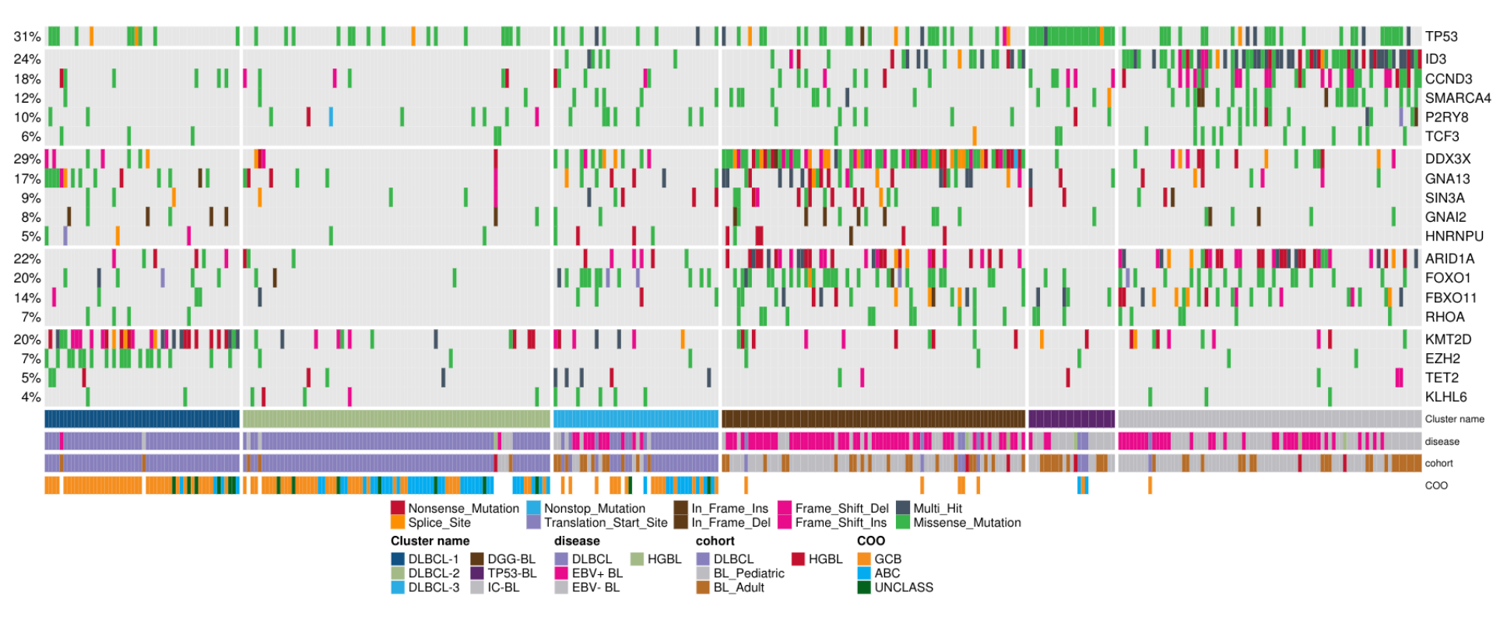
Figure 1. Overview of genetic subgroups of Burkitt lymphoma.

