 MENU SUBJECT TO CHANGE

THIS ORGANIZATION IS AN EQUAL OPPORTUNITY EMPLOYER

FOOD SERVICE DIRECTOR JENNY MICHAEL

623.474.2120 X 0716

JMICHAEL@PLCCS.ORG

ALL COMPLETE MEALS SERVED TO STAUDENTS ARE FREE OF CHARGE ADULT MEALS AND ALA CARTE ITEMS ARE AVAILABLE FOR PURCHASE

POWDERED DONUT

CHOICE OF FRUIT

MILK

CINNI MINI

PASTRY

CHOICE OF FRUIT

MILK

YOGURT

GRANOLA

CHOICE OF FRUIT

MILK

CINNAMON SWIRL

BUN

CHOICE OF FRUIT

MILK

CEREAL BAR

CHEESE STICK

CHOICE OF FRUIT

MILK

CHOCOLATE DONUT

CHOICE OF FRUIT

MILK

MINI

WAFFLES

CHOICE OF FRUIT

MILK

POP TART

CHEESE STICK

CHOICE OF FRUIT

MILK

CINNAMON

ROLL

CHOICE OF FRUIT

MILK

BANANA

BREAD

CHOICE OF FRUIT

MILK

CINNI MINI

PASTRY

CHOICE OF FRUIT

MILK

YOGURT

GRANOLA

CHOICE OF FRUIT

MILK

CINNAMON SWIRL

BUN

CHOICE OF FRUIT

MILK

CEREAL BAR

CHEESE STICK

CHOICE OF FRUIT

MILK

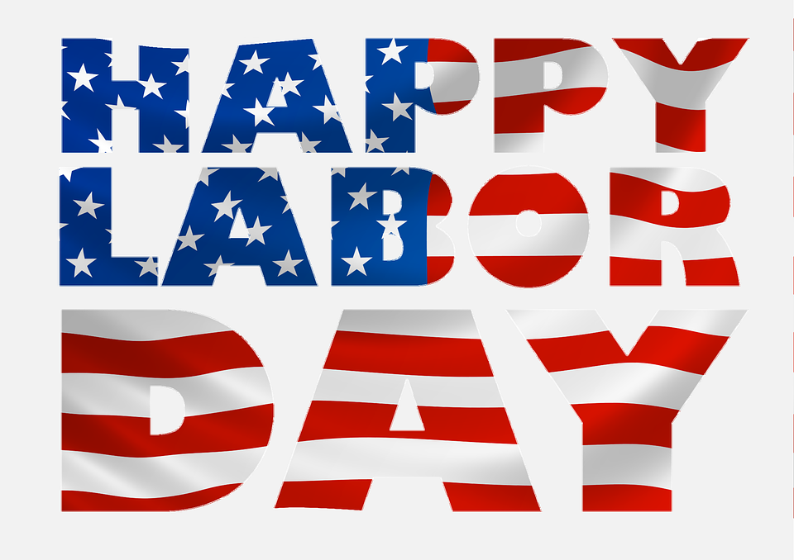

NO SCHOOL

TEACHER

IN SERVICE

**SEPTEMBER 2023**

ARTS ACADEMY AT ESTRELLA MOUNTAIN

BANANA

BREAD

CHOICE OF FRUIT

MILK

CINNAMON

ROLL

CHOICE OF FRUIT

MILK

POP TART

CHEESE STICK

CHOICE OF FRUIT

MILK

MINI

WAFFLES

CHOICE OF FRUIT

MILK

POWDERED DONUT

CHOICE OF FRUIT

MILK