 THIS INSTITUTION IS AN EQUAL OPPORTUNITY EMPLOYER

FOOD SERVICE DIRECTOR

JENNY MICHAEL

6234742120 X 876

JMICHAEL@PLCCS.ORG

ALL MEALS SERVED TO

STUDENTS ARE FREE OF CHARGE. ADULT MEALS AND ALA CARTE ITEMS AVAILABLE

FOR PURCHASE

**OCTOBER 2022**

ARTS ACADEMY AT ESTRELLA MOUNTAIN

MIDDLE SCHOOL LUNCH GRADES 5-8

HOT DOG

FRUIT AND/OR VEGETABLE

CHOICE OF MILK

REAL SLICE

CHEESE PIZZA

FRUIT AND/OR VEGETABLE

CHOICE OF MILK

ORANGE CHICKEN

WITH RICE

FRUIT AND/OR VEGETABLE

CHOICE OF MILK

CHEESE

ENCHILADA

FRUIT AND/OR VEGETABLE

CHOICE OF MILK

CORNDOG

FRUIT AND/OR VEGETABLE

CHOICE OF MILK

PANCAKES & SAUSAGE

NUGGETS

FRUIT AND/OR VEGETABLE

CHOICE OF MILK

5” ROUND PIZZA

FRUIT AND/OR VEGETABLE

CHOICE OF MILK

SPAGHETTI W/

BREADSTICK

FRUIT AND/OR VEGETABLE

CHOICE OF MILK

BEEF AND CHEESE

NACHOS

FRUIT AND/OR VEGETABLE

CHOICE OF MILK

CHICKEN

PATTY SANDWICH

FRUIT AND/OR VEGETABLE

CHOICE OF MILK

MOZARELLA STUFFED

BREADSTICK W/ SAUCE

FRUIT AND/OR VEGETABLE

CHOICE OF MILK

ITALIAN MEATBALLS W/ PASTA & BREADSTICK

FRUIT AND/OR VEGETABLE

CHOICE OF MILK

CHEESE BURGER

FRUIT AND/OR VEGETABLE

CHOICE OF MILK

CHICKEN

AND WAFFLES

FRUIT AND/OR VEGETABLE

CHOICE OF MILK

TEACHER

IN SERVICE

NO SCHOOL



BEAN & CHEESE BURRITO

FRUIT AND/OR VEGETABLE

CHOICE OF MILK

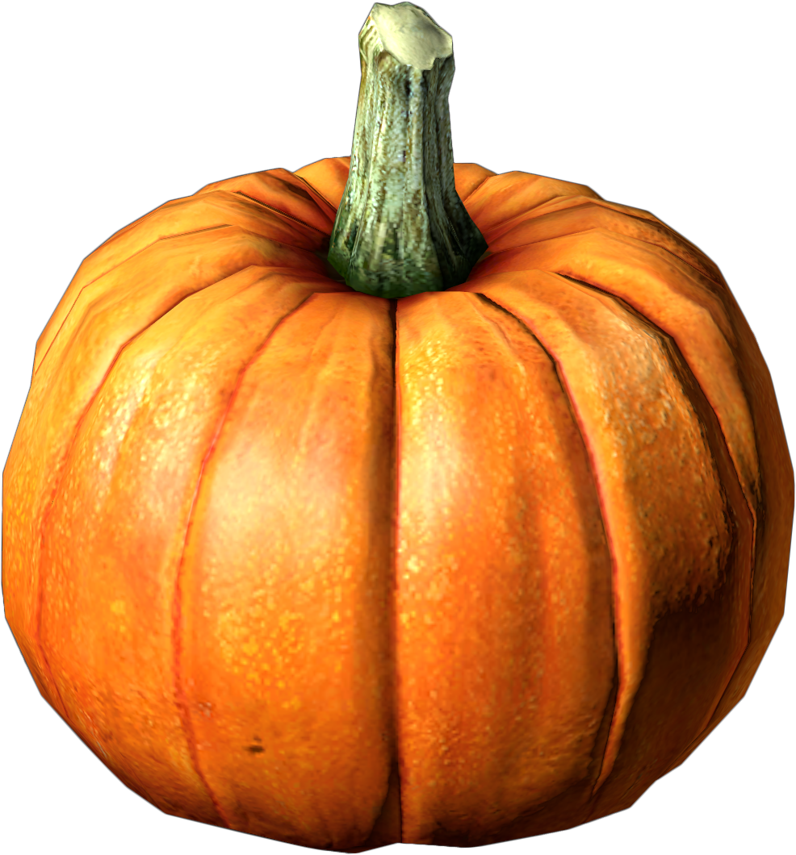

MENU IS SUBJECT

TO CHANGE

SCHOOL RESUMES

OCTOBER 11

