MENU SUBJECT TO CHANGE
ALL COMPLETE MEALS SERVED TO CHILDREN ARE FREE OF CHARGE, ALA CARTE ITEMS AVAILABLE FOR PURCHASE
NOVEMBER 2021
ARTS ACADEMY AT ESTRELLA MOUNTAIN
THIS INSTITUTION IS AN EQUAL OPPORTUNITY EMPLOYER

CHICKEN NUGGETS
GOLDFISH CRACKERS
FRUIT AND/OR VEGETABLE
CHOICE OF MILK

MEATLESS OPTIONS AVAILABLE DAILY ADULT MEALS AVAILABLE FOR PURCHASE
SNACK BAR AVAILABLE FOR MIDDLE SCHOOL CASH ONLY
FOOD SERVICE DIRECTOR JENNY MICHAEL 623.474.2120 JMICHAEL@PLCCHARTERSCHOOLS.ORG

BEAN & CHEESE BURRITO
LETTUCE / CHEESE/ SALSA
FRUIT AND/OR VEGETABLE
CHOICE OF MILK

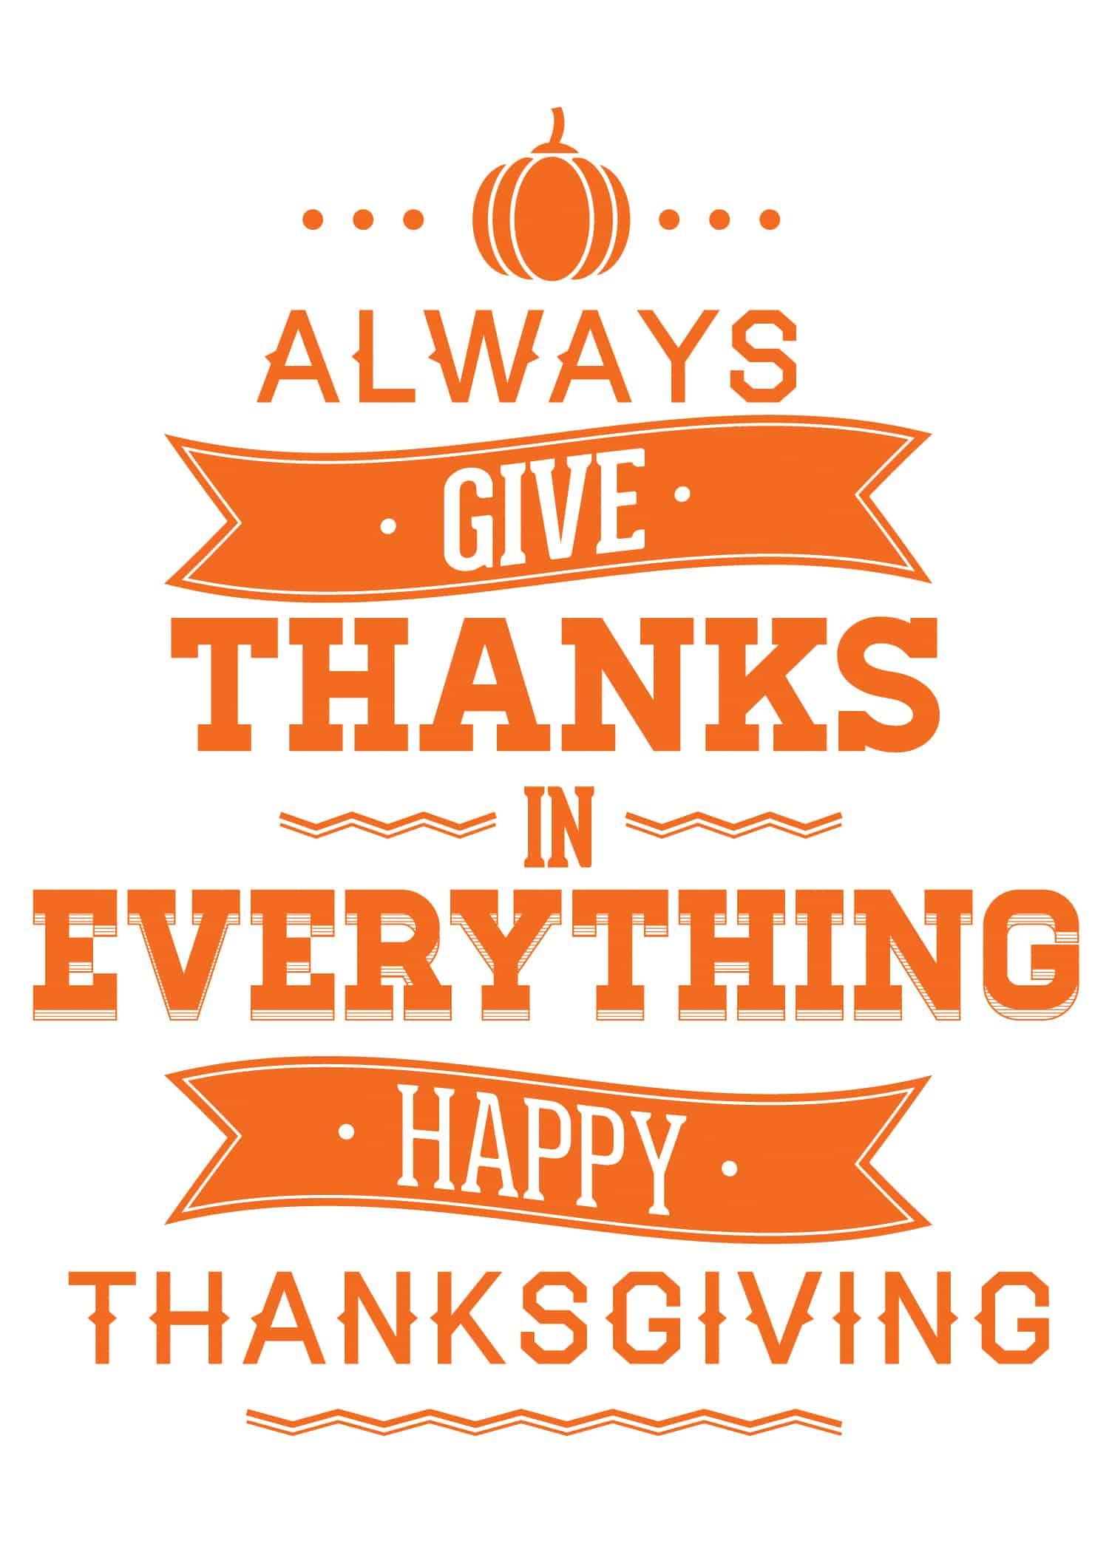
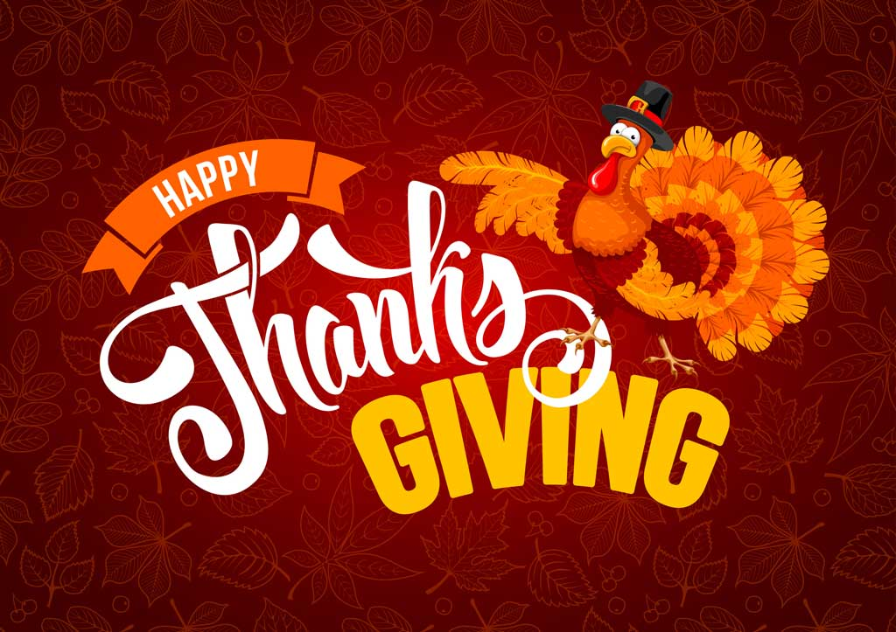

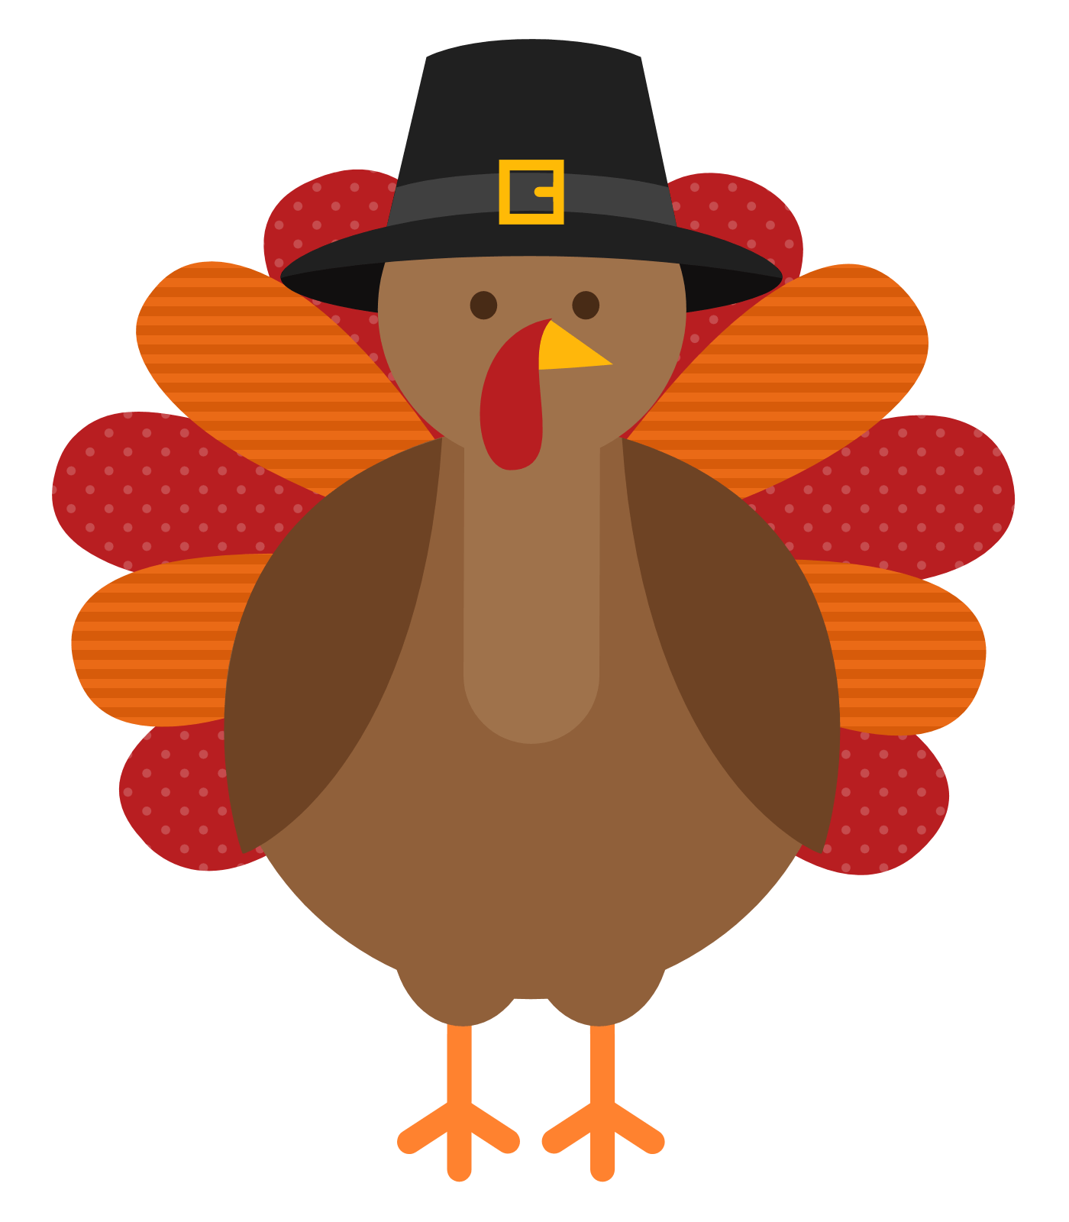

MACARONI AND CHEESE
DINNER ROLL W/ BUTTER
FRUIT AND/OR VEGETABLE
CHOICE OF MILK

BREAKFAST FOR LUNCH
CEREAL
CHEESE STICK AND/OR YOGURT
FRUIT AND/OR VEGETABLE
CHOICE OF MILK

CHEESE STUFFED
BREADSTICKS
FRUIT AND/OR VEGETABLE
CHOICE OF MILK
SPECIAL TREAT

CHICKEN NUGGETS
GOLDFISH CRACKERS
FRUIT AND/OR VEGETABLE
CHOICE OF MILK

CHICKEN PATTY
SANDWICH
DORITOS
FRUIT AND/OR VEGETABLE
CHOICE OF MILK

BEAN BOWL
TOSTIDOS
LETUCE. / CHEESE/ SALSA
FRUIT AND/OR VEGETABLE
CHOICE OF MILK

TURKEY AND CHEESE
SUBMARINE SANDWICH
SUNCHIPS
FRUIT AND/OR VEGETABLE
CHOICE OF MILK

SPAGHETTI W/ MEATSAUCE
DINNER ROLL
FRUIT AND/OR VEGETABLE
CHOICE OF MILK

BEAN & CHEESE BURRITO
LETTUCE. / CHEESE/ SALSA
FRUIT AND/OR VEGETABLE
FRUIT AND VEGETABLE
CHOICE OF MILK

CHEESE STUFFED
BREADSTICKS
FRUIT AND/OR VEGETABLE
CHOICE OF MILK
SPECIAL TREAT

MINI RAVIOLIS
DINNER ROLL
FRUIT AND/OR VEGETABLE
CHOICE OF MILK

MACARONI AND CHEESE
DINNER ROLL W/ BUTTER
FRUIT AND/OR VEGETABLE
CHOICE OF MILK

CHICKEN PATTY
SANDWICH
DORITOS
FRUIT AND/OR VEGETABLE
CHOICE OF MILK

BREAKFAST FOR LUNCH
CEREAL
CHEESE STICK AND/OR YOGURT
FRUIT AND/OR VEGETABLE
CHOICE OF MILK

SPAGHETTI W/ MEATSAUCE
DINNER ROLL
FRUIT AND/OR VEGETABLE
CHOICE OF MILK

FRENCH BREAD
PIZZA
FRUIT AND/OR VEGETABLE
CHOICE OF MILK
SPECIAL TREAT

