

CHOCOLATE

MINI DONUT

FRUIT OR JUICE

CHOICE OF MILK

VEGETARIAN OPTIONS AVAILABLE DAILY

ADULT MEALS MAY BE ORDERED ONLINE

SNACKBAR AVAILABLE FOR MIDDLE SCHOOL CASH ONLY

FOOD SERVICE DIRECTOR, JENNY MICHAEL 6234742120 X 876 [JMICHAEL@PLCCHARTERSCHOOLS.ORG](mailto:JMICHAEL@PLCCHARTERSCHOOLS.ORG)

MENU IS SUBJECT TO CHANGE

**NOVEMBER 2021**

ARTS ACADEMY AT ESTRELLA MOUNTAIN

THIS INSTITUTION IS AN EQUAL OPPORTUNITY EMPLOYER

CHOCOLATE

MINI DONUT

FRUIT OR JUICE

CHOICE OF MILK

ALL ***COMPETE*** MEALS SERVED TO A CHILD IS FREE OF CHARGE. ALA CARTE ITEMS AVAILABLE FOR PURCHASE,

POWDERED

MINI DONUTS

FRUIT OR JUICE

CHOICE OF MILK

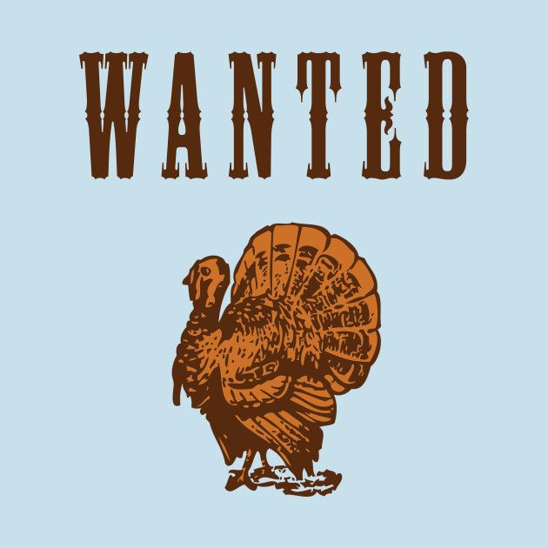

NO SCHOOL

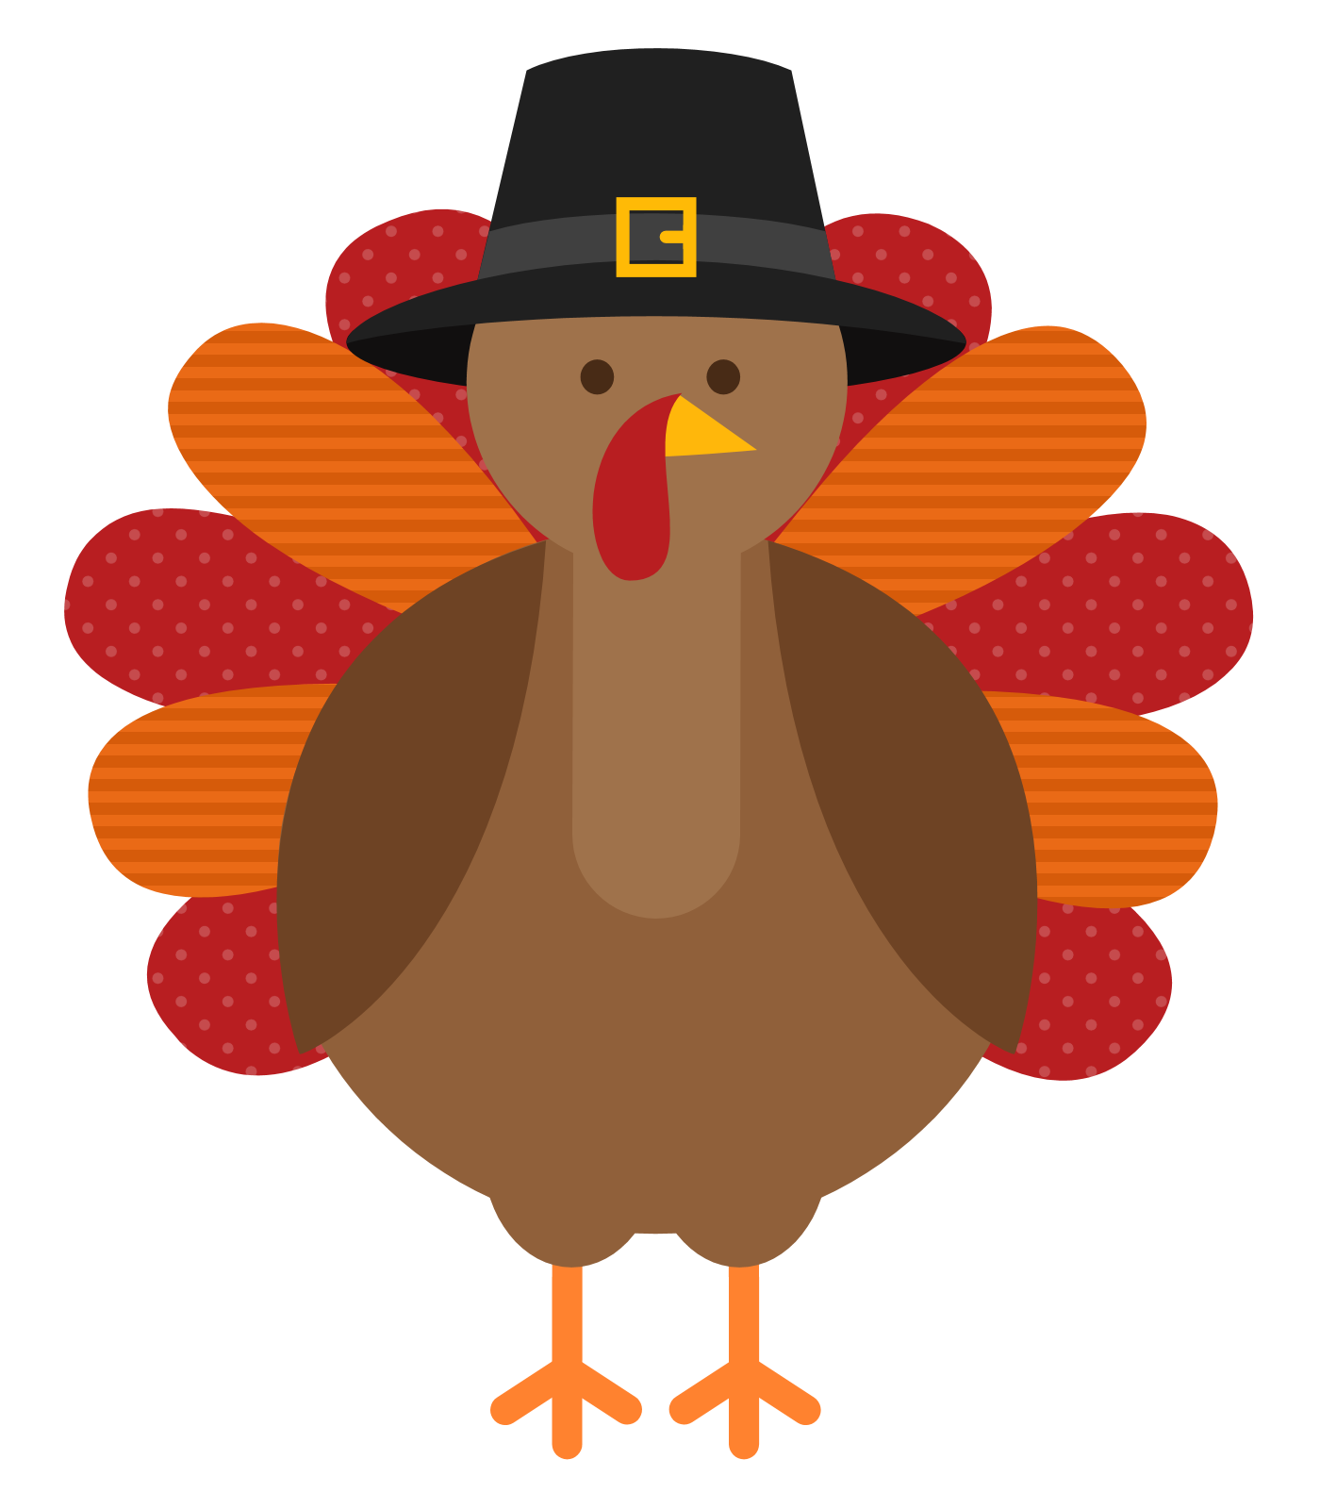

THANKSGIVING

NO SCHOOL

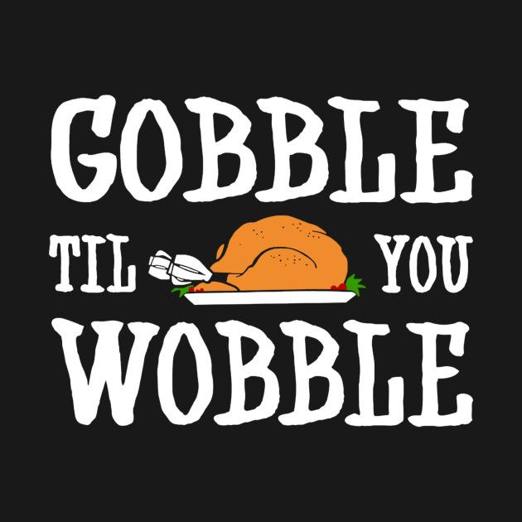

THANKSGIVING

NO SCHOOL

TURKEY AND CHEESE

ON HAWAIIAN BUN

FRUIT OR JUICE

CHOICE OF MILK

POWDERED

MINI DONUTS

FRUIT OR JUICE

CHOICE OF MILK

GRANOLA

W/ YOGURT

FRUIT OR JUICE

CHOICE OF MILK

BREAKFAST

CHEESE BAGEL PIZZA

FRUIT OR JUICE

CHOICE OF MILK

ENGLISH MUFFIN

W/EGG AND CHEESE

FRUIT OR JUICE

CHOICE OF MILK

POPTART

CHEESESTICK OR YOGURT FRUIT OR JUICE

MILK



NO SCHOOL

SUPERDONUT

CHEESE STICK OR YOGURT

FRUIT OR JUICE

MILK

PANCAKE SANDWICH

WiTH CHICKEN SAUSAGE

FRUIT OR JUICE

MILK

POWDERED

MINI DONUTS

FRUIT OR JUICE

CHOICE OF MILK

WHOLE GRAIN

CEREAL

FRUIT OR JUICE

CHOICE OF MILK

POWDERED

MINI DONUTS

FRUIT OR JUICE

CHOICE OF MILK

TURKEY AND CHEESE

ON HAWAIIAN BUN

FRUIT OR JUICE

CHOICE OF MILK

EGG AND CHEESE

BURRITO

FRUIT OR JUICE

CHOICE OF MILK

POWDERED

MINI DONUTS

FRUIT OR JUICE

CHOICE OF MILK

PANCAKE SANDWICH

WiTH CHICKEN SAUSAGE

FRUIT OR JUICE

MILK