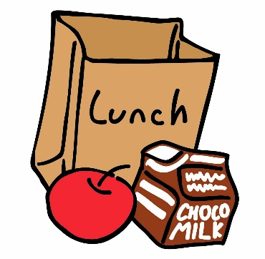Scorpion Parents

TIME CHANGES FOR MEAL PICK UP

Beginning, Tuesday March 16 the following changes will take place. The current distribution times and days will not be the same
Meals can now be picked up daily, Monday – Thursday meals can be picked up from 830a -1030p and again from 330p-530p. We will provide you with the Friday meal on Thursday. Meals will be provided for 5 days a week, not 7. Grab and go service is intended for anyone 18 years of age and under. Students eating meals on campus do not qualify for grab and go.
Should you have any questions, or need any additional information, including where you can pick up additional food, please contact the Director of Food Service.

Jenny Michael
Food Service Director
PLC Charter Schools
2504 S. 91st Avenue
Tolleson, AZ 85353
602.329.0067
jmichael@plccharterschools.org

