

**MARCH 2022**

**ARTS ACADEMY AT ESTRELLA MOUNTAIN**

**THIS ORGANIZATION IS AN EQUAL OPPORTUNUTY**

ALL COMPLETE MEALS SERVED TO STUDENTS ARE FREE OF CHARGE. ALA CARTE MEALS ARE AVAILABLE FOR PURCHASE. ADULT MEALS ALSO AVAILABLE FOR PURCHASE

MINI WAFFLES

FRUIT OR JUICE

MILK

FOOD SERVICE DIRECTOR

JENNY MICHAEL 623.474.2120 X 876

[JMICHAEL@PLCCHARTERSCHOOLS.ORG](mailto:JMICHAEL@PLCCHARTERSCHOOLS.ORG)

GRANOLA

YOGURT

FRUIT OR JUICE

MILK



CEREAL

FRUIT OR JUICE

MILK

SUPERDONUT

FRUIT OR JUICE

MILK

TORTILLA WITH

EGG AND CHEESE

FRUIT OR JUICE

MILK

TURKEY AND CHEESE

ON HAWAIIAN BUN

FRUIT OR JUICE

MILK

MUFFIN

FRUIT OR JUICE

MILK

POPTART

FRUIT OR JUICE

MILK

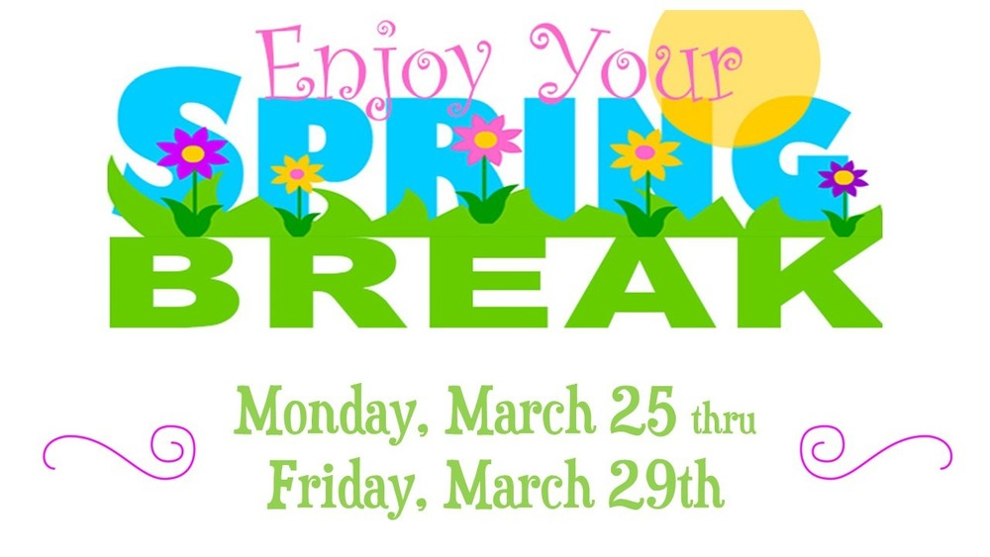

EGG & CHEESE

ENGLISH MUFFIN

FRUIT OR JUICE

MILK

BREAKFAST BAGEL

FRUIT OR JUICE

MILK

CINNABUN

FRUIT OR JUICE

MILK

NO SCHOOL

TEACHER

IN-SERVICE

PANCAKE AND SAUSAGE

SANDWICH

FRUIT OR JUICE

MILK

BREAKFAST BAGEL

FRUIT OR JUICE

MILK

CINNABUN

FRUIT OR JUICE

MILK

CEREAL BAR

FRUIT OR JUICE

MILK

EGG & CHEESE

ENGLISH MUFFIN

FRUIT OR JUICE

MILK

BANANA BREAD

FRUIT OR JUICE

MILK