 MIDDLE SCHOOL

FOOD SERVICE DIRECTOR

JENNY MICHAEL

623.474.2120

JMICHAEL@PLCCS.ORG

ALL COMPLETE MEALS SERVED TO STUDENTS ARE FREE OF CHARGE

ALA CARTE AVAILABLE FOR

PURCHASE

ADULT MEALS AVAILABLE FOR

PURCHASE

**SEPTEMBER 2022**

ARTS ACADEMY AT ESTRELLA MOUNTIAN

THIS EMPLOYER IS AN EQUAL OPPORTUNITY EMPLOYER

SPAGHETTI W/ MEATSAUCE

BREADSTICK

FRUIT AND/OR VEGETABLE

CHOICE OF MILK

JTM PANCAKE AND

SAUSAGE NUGGETS

FRUIT AND/OR VEGETABLE

CHOICE OF MILK

ARDELLA MINI TWIN

PIZZA SLIDERS

FRUIT AND/OR VEGETABLE

CHOICE OF MILK

JTM SPAGHETTI

WITH BREADSTICK

FRUIT AND/OR VEGETABLE

CHOICE OF MILK

JTM PREIMIUN BEEF

AND CHEESE NACHOS

FRUIT AND/OR VEGETABLE

CHOICE OF MILK

TYSON CHICKEN

PATTY SANDWICH

FRUIT AND/OR VEGETABLE

CHOICE OF MILK

ARIZONA GOLD

BEAN & CHEESEE BURRITO

FRUIT AND/OR VEGETABLE

CHOICE OF MILK

GILARDIS

MOZZARELLA STUFFED

BREAD STICK W/ MARINARA

FRUIT AND/OR VEGETABLE

CHOICE OF MILK

ARDELLAS

ITALIAN MEATBALLS

PENNE PASTA

FRUIT AND/OR VEGETABLE

CHOICE OF MILK

CHEESEBURGER

FRUIT AND/OR VEGETABLE

CHOICE OF MILK

TYSON CHICKEN NUGGETS

WAFFLES

FRUIT AND/OR VEGETABLE

CHOICE OF MILK

GILARDI’S REAL SLICE

CHEESE PIZZA

FRUIT AND/OR VEGETABLE

CHOICE OF MILK

OVEN

ROASTED CHICKEN

FRUIT AND/OR VEGETABLE

CHOICE OF MILK

]

LOS CABOS CHEESE

ENCHILADAS

FRUIT AND/OR VEGETABLE

CHOICE OF MILK

TYSON CORNDOG

GOLDFISH CRACKERS

FRUIT AND/OR VEGETABLE

CHOICE OF MILK

NO SCHOOL

LABOR DAY

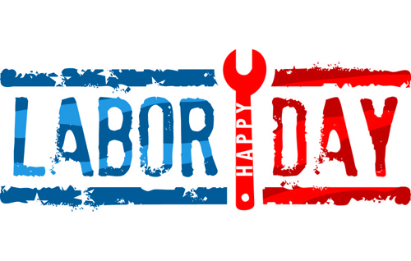

NO SCHOOL

TEACHER IN-SERVICE

BUTTER BALL

HOT DOG

FRUIT AND OR VEGETABLE

CHOICE OF MILK

TYSON CORNDOG

GOLDFISH CRACKERS

FRUIT AND/OR VEGETABLE

CHOICE OF MILK

LOS CABOS CHEESE

ENCHILADAS

FRUIT AND/OR VEGETABLE

CHOICE OF MILK

OVEN

ROASTED CHICKEN

FRUIT AND/OR VEGETABLE

CHOICE OF MILK

GILARDIS REAL SLICE

CHEESE PIZZA

FRUIT AND/OR VEGETABLE

CHOICE OF MILK