

**All complete meals served to students are free of charge. Ala carte items available for purchase**

**FOOD SERVICE DIRECTOR**

**JENNY MICHAEL 623.474..2120 JMICHAE@PLCAAEM/.ORG**

PANCAKE AND SAUSAGE

SANDWICH

FRUIT AND/OR JUICE

CHOICE OF MILK

SUPERDONUT

YOGURT OR CHEESE STICK

FRUIT AND/OR JUICE

CHOICE OF MILK

MENU SUBJECT TO CHANGE

THIS INSTITUTION IS AN EQUAL OPPORTUNITY EMPLOYER

Winter break

December 20, 2021-January 3, 2022

SCHOOL RESUMES JANUARY 4TH 2022

WINTER BREAK

WINTER BREAK

WINTER BREAK

WINTER BREAK

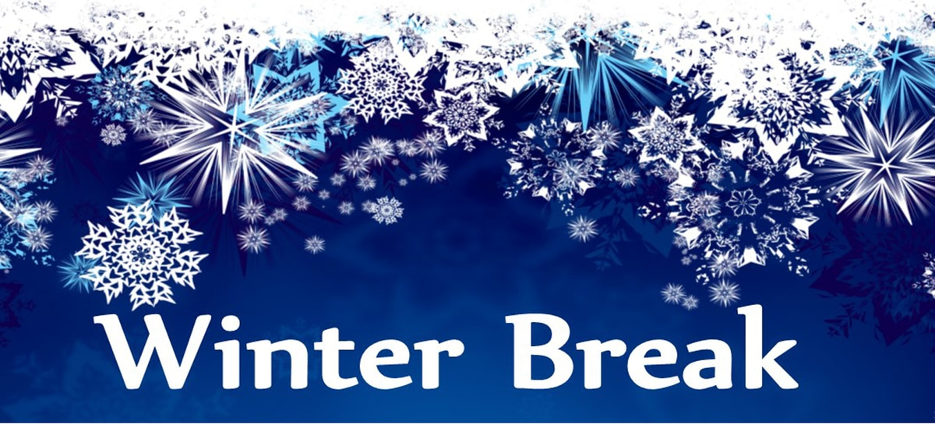

GRANOLA

W/ YOGURT

FRUIT AND/OR JUICE

CHOICE OF MILK

BLUEBERRY MUFFIN

FRUIT OR JUICE

CHOICE OF MILK

BREAKFAST

PIZZA BAGEL

FRUIT AND/OR JUICE

CHOICE OF MILK

EGG AND CHEESE

ENGLIST MUFFIN

FRUIT AND/OR MILK

POPTART

YOGURT

FRUIT AND/OR JUICE

CHOICE OF MILK

BANANA BREAD

FRUIT ANDOR JUICE

CHOICE OF MILK

FRUIT FRUDEL

FRUIT AND/OR JUICE

CHOICE OF MILK

BLUEBERRY MUFFIN

CHEESE STICK

FRUIT AND/OR JUICE

CHOICE OF MILK

CEREAL

FRUIT AND/OR JUICE

CHOICE OF MILK

**DECEMBER 2021**

**ARTS ACADEMY AT ESTRELLA MOUNTAIN**

CEREAL BAR

YOGURT

FRUIT OR JUCIE

CHOICE OF MILK

EGG AND CHEESE

TORTILLA

FRUIT AND/OR JUICE

CHOICE OF MILK

WINTER BREAK

WINTER BREAK

WINTER BREAK

WINTER BREAK