THIS INSTITUTION IS AN EQUAL OPPORTUNITY EMPLOYER
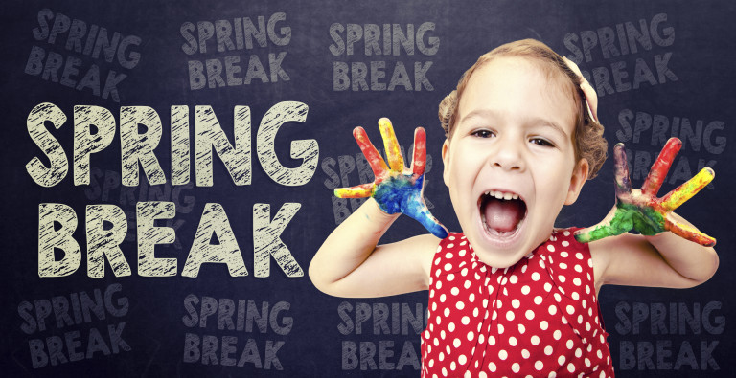
ALL MEALS SERVED TO STUDENTS ARE FREE OF CHARGE
ALA CARTE AND ADULT MEALS ARE AVAILABLE FOR PURCHASE
MARCH 2023
ARTS ACADEMY AT ESTRELLA MOUNTAIN
MIDDLE SCHOOL
FOOD SERVICE DIRECTOR – JENNY MICHAEL
623.474.2120 X 876
JMICHAEL@PLCCS.ORG

EGG AND CHEESE
SLIDERS
FRUIT AND/OR JUICE
CHOICE OF MILK

SCHOOL RESUMES
ON TUESDAY
MARCH 21, 2021

SPRING BREAK
NO SCHOOL
ALL WEEK

TACO STICK
BEEF AND CHEESE
FRUIT AND/OR JUICE
CHOICE OF MILK

HONEY GLAZED
BUN
FRUIT AND/OR JUICE
CHOICE OF MILK

GRANOLA
YOGURT
FRUIT AND/OR JUICE
CHOICE OF MILK

[
FRENCH TOAST
WITH SYRUP
FRUIT AND/OR JUICE
CHOICE OF MILK

CHOCOLATE DIPPED
DONUT
FRUIT AND/OR JUICE
CHOICE OF MILK

GRILLED
CHEESE SANDWICH
FRUIT AND/OR JUICE
CHOICE OF MILK

BLUEBERRY
MUFFIN
FRUIT AND/OR JUICE
CHOICE OF MILK

CINNAMON
BREAKFAST COOKIE
FRUIT AND/OR JUICE
CHOICE OF MILK

BLUEBERRY
MUFFIN
FRUIT AND/OR JUICE
CHOICE OF MILK

NO SCHOOL
TEACHER
IN-SERVICE

CINNAMON
SWIRL BUN
FRUIT AND/OR JUICE
CHOICE OF MILK

CINNAMON
BREAKFAST COOKIE
FRUIT AND/OR JUICE
CHOICE OF MILK

GRANOLA
YOGURT
FRUIT AND/OR JUICE
CHOICE OF MILK

HONEY GLAZED
BUN
FRUIT AND/OR JUICE
CHOICE OF MILK

CHOCOLATE DIPPED
DONUT
FRUIT AND/OR JUICE
CHOICE OF MILK

FRENCH TOAST
WITH SYRUP
FRUIT AND/OR JUICE
CHOICE OF MILK

CHEESE QUESADILLA
FRUIT AND/OR JUICE
CHOICE OF MILK

