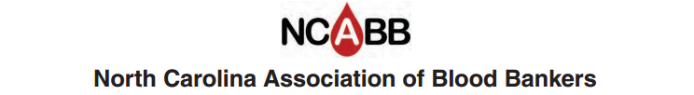

Job Description

Title: President Elect

Term: 1 Year
Elected by general membership at fall seminar
Automatic transition to President the following year
Has voting rights

Job Summary

- Assist the President in all duties

- Perform the duties of the President in the President’s absence

- Serve as editor of the Newsletter

Publish 3 to 4 per year: Suggested schedule
    - November-December: include pictures and summary of fall seminar, letter from president, introduction of new board members, calendar of events, etc.
    - January-February: Membership renewal form, nomination for service award form, preliminary program and registration form for spring workshop, calendar of events, etc.
    - May-June: include pictures and summary of spring workshop, preliminary program for fall seminar, registration form for fall seminar, service award nomination form, Gabriel scholarship form, calendar of events, pictures and summary of Carolinas Clinical Connections meeting if available, etc.
    - August: proposed changes to the By-laws if indicated, proposed slate of new officers. This may be done electronically.

- Serve as chair of the Nominating Committee for new board members

