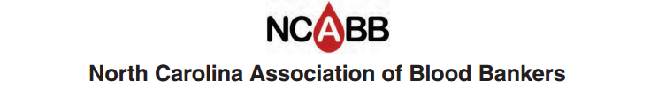

Job Description

Title: President

Term: 1 Year
Follows being President Elect
Begins after election of officers at annual seminar
Has voting rights

Job Summary

- Conduct annual business meeting at fall seminar
- Select a search committee to study locations for future annual seminar
- Schedule and conduct board meetings. Suggested schedule:
September, January, April, and July
- Send agenda for board meetings to secretary for electronic distribution to board members.
Invite all committee members and advisory persons
- Appoint local arrangements chairperson for fall seminar
- Appoint program co-chairs for fall seminar
- Send thank you notes to all committee members and board members
- Keep abreast of the business of the NCABB by frequent communications with board
members
- Forward ideas and suggestions from the general membership to the board
- Solicit reports from committees, as needed
- Forward pertinent information to the webmaster for inclusion on the website
- Sign all indicated documents on behalf of the organization
- Rotate to Past President position on the board following term as president

