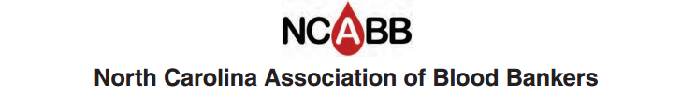

Job Description

Title: Mentor

Term: 1 Year
Previously served on board
Elected by general membership
Has voting rights
May be re-elected

Job Summary

- Attend board meetings, usually four per year: September, January, April, and July

- Make and vote on motions presented at board meeting.

- Conduct business in accordance with By-laws of the NCABB.

- Attend general business meeting during fall seminar.

- Consult about previous NCABB decisions or practice

- Offer historic information, guidance and advice.

