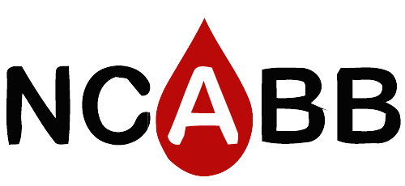**47th Annual Fall Meeting 2019**

Save the Dates

Make plans now to join us at this year’s **Fall Meeting** in **Concord, North Carolina**! The meeting will be held at the Embassy Suites Golf Resort & Spa on   
**September 16– 17th**

Come one day early and attend the **Leadership Workshop** on **September 15th**

**\*\*P.A.C.E.® approved CE credits\*\***

**Join. Connect. Learn.**

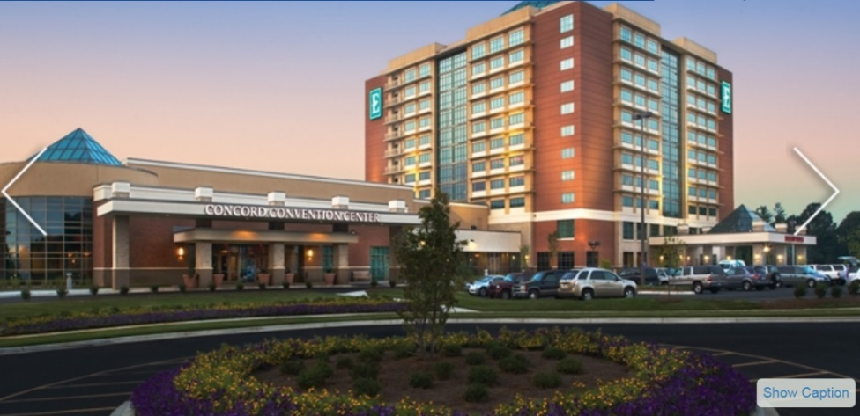

The Embassy Suites offers their guests free made-to-order breakfast, complimentary drinks and snacks at the evening reception and every room is a **two-room suite**. There is an on-site spa and hotel guests receive discount greens fees for the Rocky River golf course.

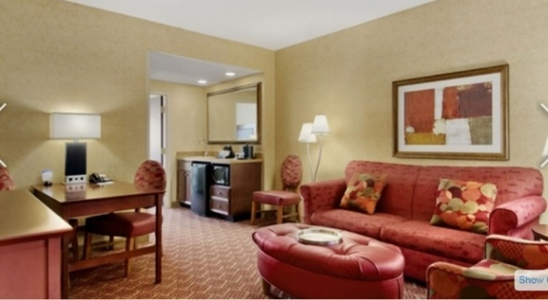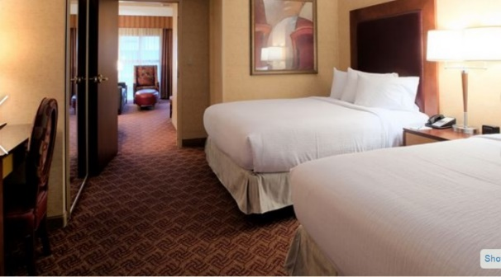

**More info on program and registration coming soon !**