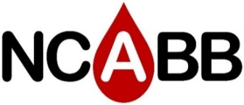
2021 Registration for Sponsorship
Virtual Fall Meeting, September 13th, 2021

Check Here | Sponsorship Level | Amount | What’s Included
 | Gold Sponsor  (1 Available) | $500 | - Sponsor presentation with Q&A during lunch break (45 minutes)  - Logo on NCABB’s website  - (1) Complementary registration to our meeting (individual)
 | Silver Sponsor  (2 available) | $250 | - 2 Break-out sessions for 20 minutes each for morning and afternoon breaks  - Logo on NCABB’s website  - (1) Complementary registration to our meeting (individual)
 | Meeting Sponsor (Unlimited) | $100 | - Promotional slide(s) displayed intermittently throughout virtual program  - Logo on NCABB’s website  - (1) Complementary registration to our meeting (individual)
*Please respond and forward presentation material/slides to Lindsey Lima at lhrichak@gmail.com on or before August 16, 2021.
All slides must be prepared in 16:9 Slide Ratio Wide Screen Format
Organization Name: _______________________________________________
Contact Name and Email: _____________________________________
Payment
Please choose payment method:
Check: Make check payable to NCABB, Inc. PO Box 34213 Charlotte, NC 28234
Credit Card: You will be contacted by our Treasurer for online payment information
*Please direct any questions to NCABB’s Vendor Chair, Lindsey Lima, at lhrichak@gmail.com*

