Health Risk Assessment Step by Step Instructions
Visit MyBleKC.com
Login. If you are a first time visitor, click on REGISTER NOW. Please have your member ID card available to reference.
Go To A Healthier You.
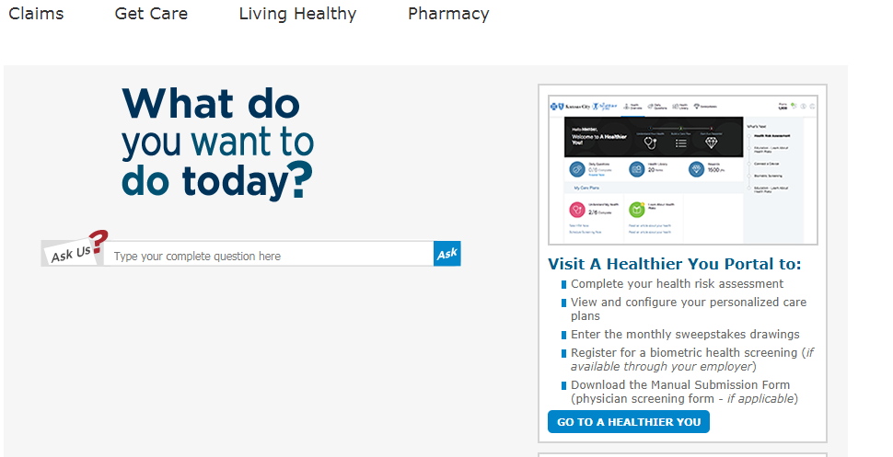
Continue.
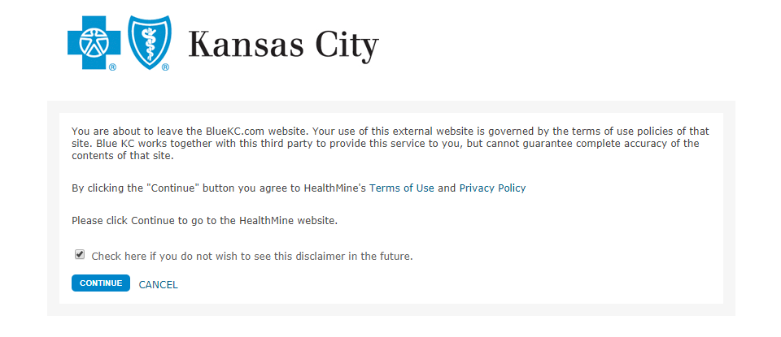

Continue again.
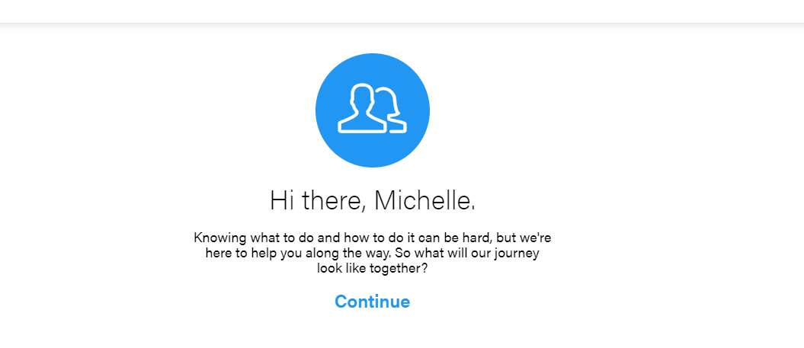
Let’s get started!
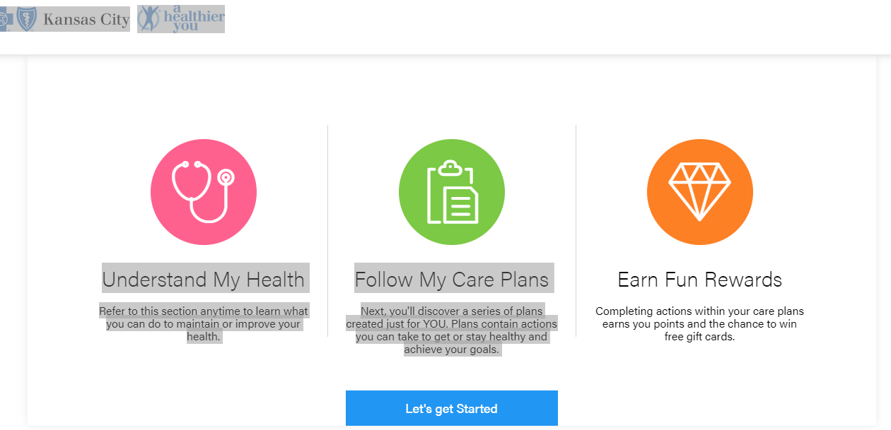
Answer a few basic questions and then hit NEXT.
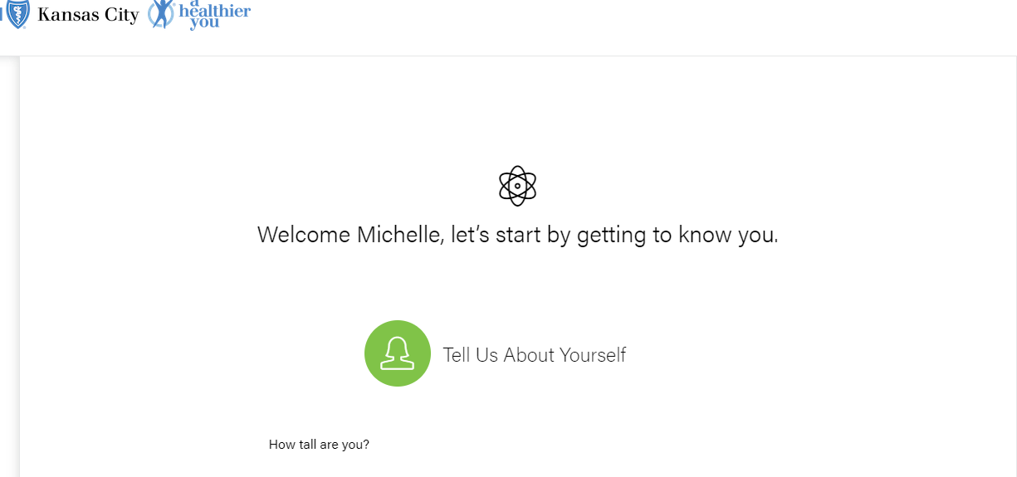

Let’s Connect a Device. This is optional. If you choose not to connect click on FINISH.
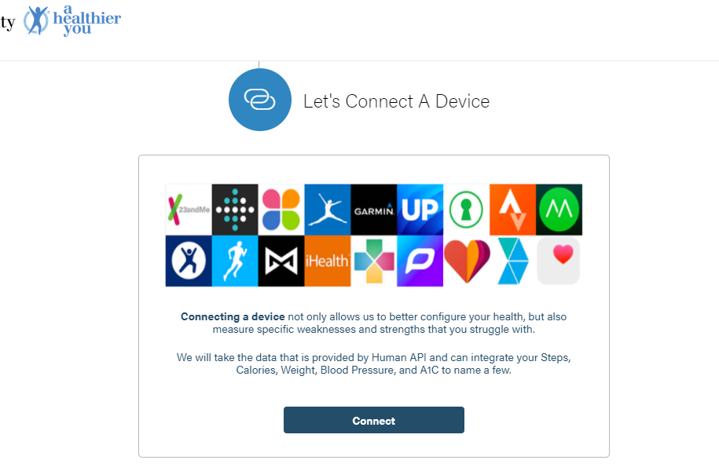
Finish.
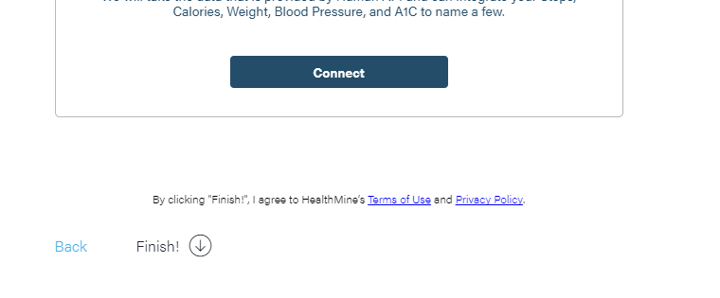

Continue.
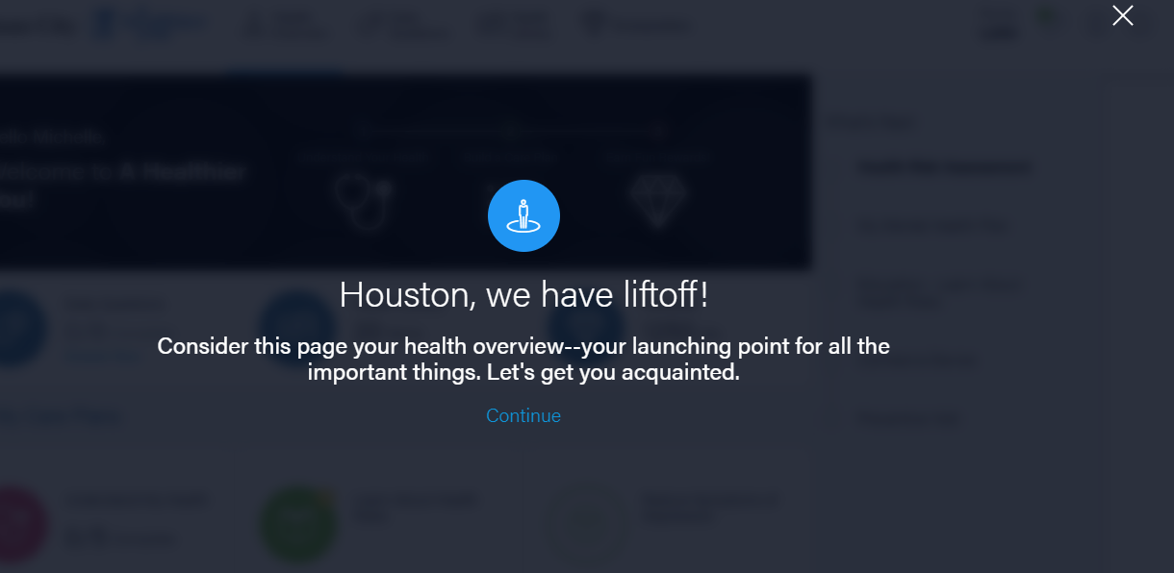

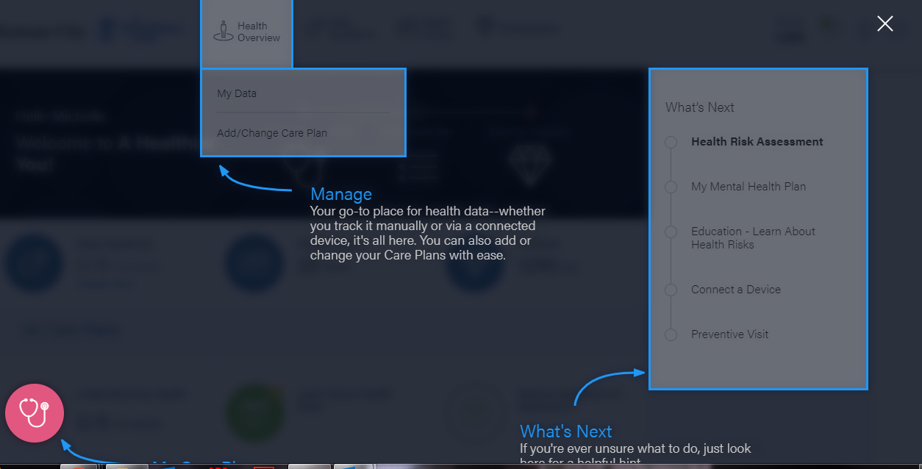

Click on the Health Risk Assessment on the right side of the page under “What’s Next”.
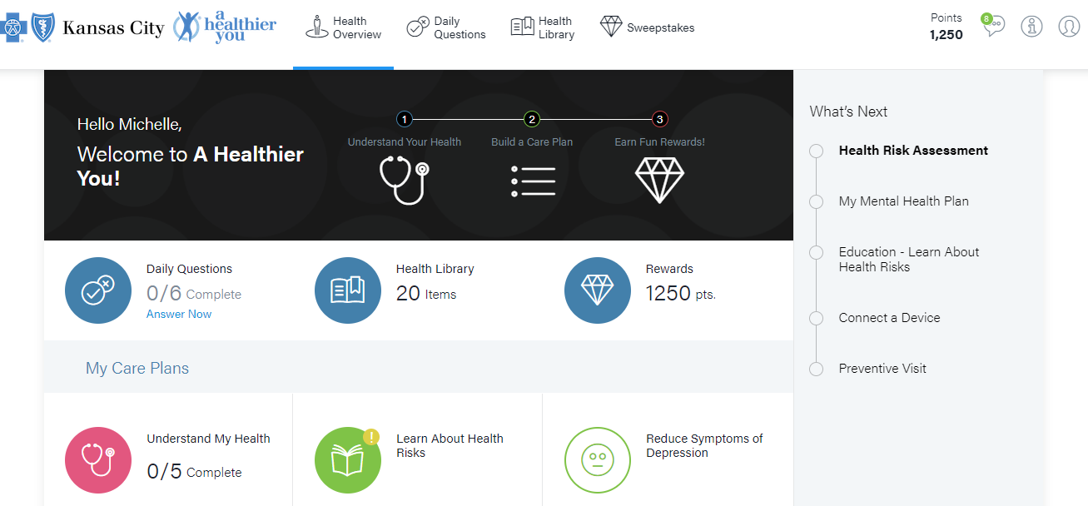
Start Assessment!
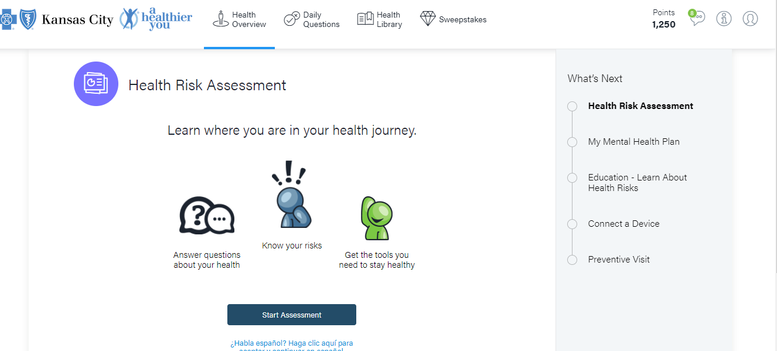

Save and close after the last question has been answered!
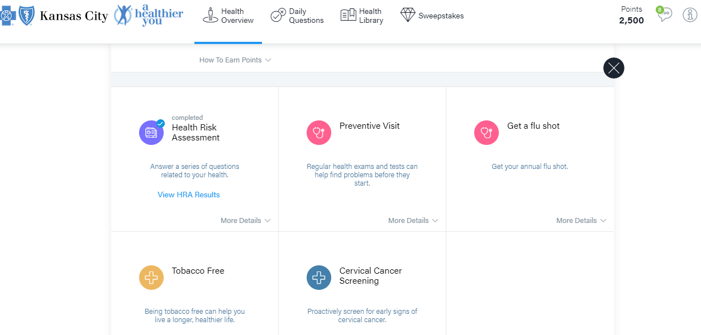
You should receive an email after you complete the assessment.
