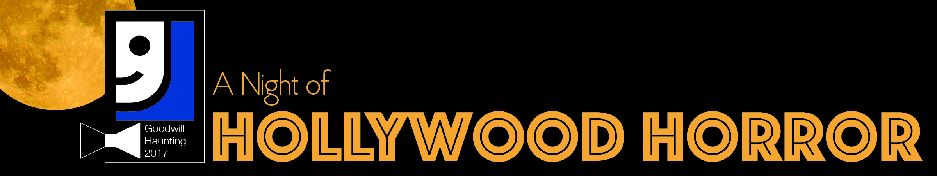

Dear Community Member,

On October 13th, 2017, Goodwill of Western Missouri and Eastern Kansas is hosting our first annual Goodwill Haunting fundraiser at The Brass on Baltimore.

Goodwill’s mission is to empower people with disadvantages and different abilities to earn and keep employment through individualized programs and services. In fact, 90 cents of every dollar Goodwill spends supports our mission – and it’s all local, right here in our region.

Wait, Goodwill isn’t just about providing cheap stuff? No! The resale stores are a means to fund our mission – and our mission is so much more than our stores.

Goodwill empowers job seekers to earn and keep employment. We do that with a variety of different programs. Programs that help at-risk youth who haven’t had a consistent role model to demonstrate what working looks like. Programs that help older community members reenter the workforce in the age of the internet. Programs that help differently-abled people maximize their abilities to contribute to the workforce.

Because we know that work is more than a paycheck. It’s a resounding victory for the individual, for their family and for our entire community.

So how can you help?

Donate an auction item.

Our event will draw 300 community influencers as well as hundreds of other supporters who will have the opportunity to access the action online. Your organization will be promoted along with other supporters of Goodwill Haunting. And, all donations are tax deductible.

Thank you for your support of Goodwill.

Goodwill’s Tax ID number is: 43-1125281

