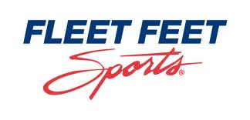
FLEET FEET SPORTS 5K SNOWSHOE RACE

Sunnycrest Park February 16, 2013 at 9:30 a.m.

Name:________________________________
Address:______________________________________________________________________
Age:____ Date of Birth:________ Sex:___
Email:________________________________
Emergency Contact (Name and Phone):

_______________________________________________________

Waiver: I know that running/walking is a potentially hazardous activity. I attest and verify that I am medically able and physically fit to participate in this training program/race. In consideration of your accepting this entry, I the undersigned intending to be legally bound, hereby for myself, executors and administrators, waive and release any and all claims I may have against Fleet Feet Sports, its employees, volunteers, Sunnycrest park, Syracuse parks; their representatives, successors and assigns for any and all injuries suffered by me during participation in said training program. I hereby grant permission to Fleet Feet Sports and any other sponsors of this program to use any record containing my likeness for any purpose whatsoever.

Signature _________________________________________

Parent (if under age 18)______________________________

Pre-Registration $20, Race Day $25
Make Checks payable to Fleet Feet Sports
Send to:
Attn. Fred Joslyn
Fleet Feet Sports
5800 Bridge St.
East Syracuse, NY
13057

