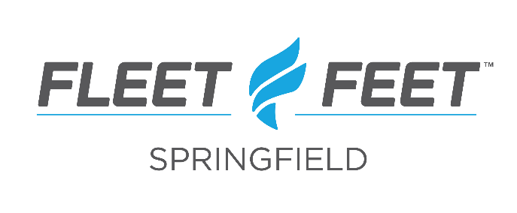
Assistant Retail Experience Manager
The Rundown:
As an Assistant Retail Experience Manager, you will work to support the Retail Experience Manager in the day-to-day and long-term success of retail staff. This position will help create the best customer experience by focusing on what matters most, the team. You will assist with recruiting, onboarding, coaching, performance management, training, and education of our Retail Sales Associates, or Outfitters, as we call them. Joining Fleet Feet is joining a team and a community that ignites and promotes running and fitness. We pride ourselves on putting people first and know that what we do each day does not happen anywhere else, for staff or customers. We truly believe that running changes everything.
Qualifiers:
- Available to work a flexible schedule, including days, evenings, weekends and holidays
- Demonstrated leadership ability with at least 1 year of retail experience in a customer-facing sales setting
- Passion for managing, training, motivating employees
- Can own and manage administrative tasks, customer interactions and a fast-paced environment while staying organized
- Fosters growth of others through recognition, coaching and development opportunities
- Promotes individual and team performance by setting expectations, delegating and by providing tools and resources
- Builds and maintains trust from staff and customers by using sound judgement
- Passionate, positive, self-motivated and detail-oriented
- Willing to go above and beyond when needed
- Communicate professionally with customers and team
- Deliver the best customer experience by creating a positive staff culture with a focus on performance management and education.
- Support all Fleet Feet initiatives, activities and functions
- Applicants are a minimum of 18 years of age
- High school diploma or GED preferred
Perks:
- High energy and fun atmosphere
- Training and advancement opportunities within the Fleet Feet brand
- Community involvement and community service activities
- Employee discount on your favorite gear!
Want to join our Team?
Are you looking to turn your passion into your career, work with like-minded people in a fast-paced, fun and customer-centric environment? Then we want you! Email application and resume to meagan@fleetfeetspringfield.com. Be sure to reference this job and tell us why you’d be a great fit with our team.
**This job description is not an employment agreement or contract. Management has the exclusive right to alter this job description at any time without notice.

