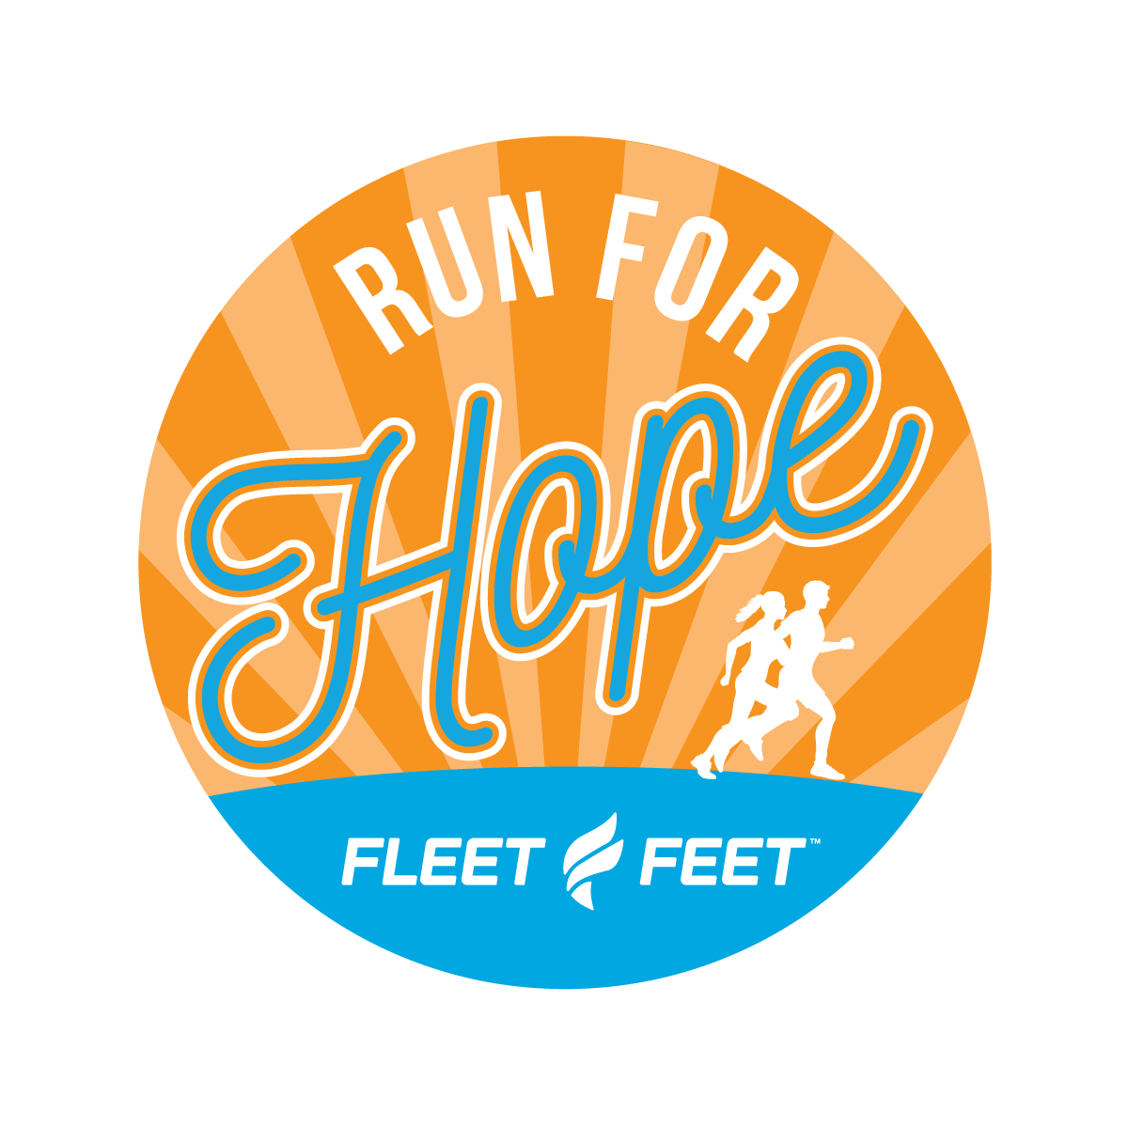

Run For Hope
We would like to invite you to join us as a Sponsor for the 10th Annual Run For Hope on April 7th, 2024 to benefit Home Sweet Home Ministries. Proceeds from this event will touch the lives of the hungry, homeless, and hurting by providing them with food, shelter, and hope. Events include a 10K, 5K and Kids Run. Sponsorship opportunities are listed below. We expect approximately 250 runners to participate and an additional 50 volunteers, family members, and supporters will be in attendance.

$250 sponsorship
- Logo and link to sponsor website on race registration web page
- Multiple sponsorship recognition posts on social media
- Large logo on back of race t-shirt
- Two complimentary race entries and t-shirts
- Opportunity to set up an informational table or booth on race day
- Placement of promotional item in the race goodie bag

$100 sponsorship
- Proportionally sized logo on back of race t-shirt
- Placement of promotional item in the race goodie bag
- One complimentary race entry and t-shirt
- Logo on race web page
- Sponsorship recognition on social media
***We are extremely grateful for your consideration of a sponsorship that supports an organization that gives the necessary tools for changed lives and renewed hope for individuals in need in our community, our goal for this year is to raise $10,000 to benefit the services of Home Sweet Home Ministries any help you can give is greatly appreciated***

2024 Run For Hope
Sponsorship Form

Name of Organization
Contact Person / Title
Address
Telephone
Email
Sponsorship Level | Amount Enclosed: $

Feel free to either return this form with your check payable to
Fleet Feet Bloomington
105 Krispy Kreme Drive #5
Bloomington, IL 61704
OR (new this year!) use the QR Code above to send your donation!

You will receive a receipt for your donation from Home Sweet Home Ministries after the race on April 7th, 2024

Please send high quality version of company logo to julie@fleetfeetbloomington.com

All sponsorship donations are greatly appreciated, but in order to be on the t-shirt or receive a race entry with t-shirt we must have your information by March 22nd, 2024

https://www.fleetfeet.com/s/bloomington/races/run-for-hope

